Juliette (Ory) Maurin
February 2, 1885 – August 21, 1964

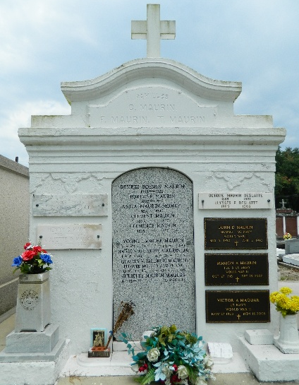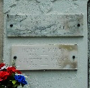

MAURIN - On Friday, August 21, 1964, at 12:15 o'clock a.m., JULIETTE ORY, wife of the late Henry Maurin Sr, mother of Mrs. Alvin Cambre, Henry Jr., Marion and John Daniel Maurin and Mrs. Victor Maquar, all of Laplace, La, also survived by 10 grandchildren, age 79 years.

Relatives and friends of the family, also Shell Oil Co, VFW Post No 3337 Laplace, La, Woodmen of the World of Laplace, faculty of St Joan of Arc School and Ladies Altar Society, are invited to attend the funeral. Services from Millet Funeral Home, Laplace, La. on Saturday, August 22, 1964, at 9:30 o'clock a.m. Religious services at St Joan of Arc Church, Laplace, La. Interment in St Peter Cemetery, Reserve, La.

The Times-Picayune, New Orleans, Louisiana
August 22, 1964, p. 2

