Louis Joseph Maurin Sr.
November 15, 1891 – March 7, 1985

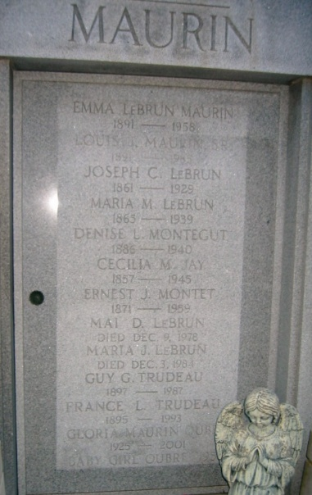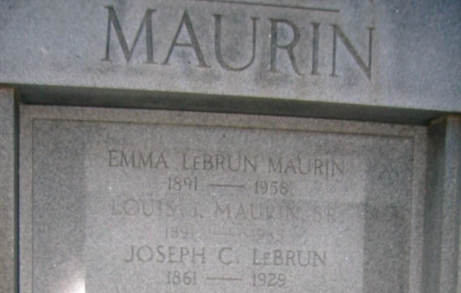
Photo by Bobby

Louis Joseph Maurin was born in 1891 in Reserve Louisiana. His father, Fortune Maurin came to America in 1875 from France; and settled in Reserve. He took up the baking trade and soon became a master baker. In 1884 he married Desiree Bossier. Louis had three younger brothers, Fortune (Jr.), Horace, Etienne, and two older sisters, Denise, and Lena. He began his education in 1898 at a small school in Reserve. Then he attended Infant Jesus College in Gretna. After outgrowing the age limit, he went to Holy Cross College in New Orleans. He boarded at both schools. At age fourteen, he left school to help his father in the bakery. The people he met in school helped shape his life of service to his community. In 1914, he married Emma LeBrun, the daughter of Joseph C. LeBrun and Maria Montet LeBrun. They had seven children: Elaine, Marjorie, Louis Joseph (Jr.), Marie Therese, Gloria Mae, Joseph LeBrun, and Jo Anne. When Louis was four years old, his father bought him a "magic lantern machine" which was a type of projector, and that planted the seed that became "Maurin's Theatre"
**
LOUIS J. MAURIN, SR. – THE ENTERTAINMENT KING OF THE RIVER PARISHES
By: Gerard Montz
Hooray for Hollywood and Hooray for Louis J. Maurin, Sr., the man who introduced films and motion pictures to the River Parishes. One of his first accomplishments in the movie business in the early 1900's was the showing of silent films at Jefferson College in Convent, Louisiana with the help of Father Henri George. There was obviously a need for this type of entertain-ment in the region, so in 1918 Mr. Maurin opened up a silent movie theater (called the Liberty Theatre) inside of the Sugar Belt Club building, later called the Club Café in Reserve, Louisiana. Advertisements for the theatre at the time proclaimed high-class motion pictures and dancing. One of the first films shown was Many Miles Minter in "Charity Castle" which consisted of five reels of film. Charley Chaplin films were later shown. In addition to the movies, live vaudeville acts were presented.
With the movies came dances at Maurin's Liberty Park. The club and the adjoining fairgrounds (pavilion) were a favorite gathering place for local residents to dance and listen to the music of Toot Johnson, Celestin's Tuxedo Orchestra and Claiborne Williams just to name a few. An advertisement for the dances read as follows: "Dancing in Reserve has become a regular occurrence. The best floor and the best orchestra in the levee section. Everybody welcome."
With all of this activity occurring in Reserve, it was only natural that Mr. Maurin would set his eyes elsewhere to expand his movie operation. In 1927, he became a stockholder in the LaPlace Amusement Company, Incorporated. Silent movies were shown in the old Woodmen of the World building in LaPlace, Louisiana. The Woodmen Hall, as it was sometimes referred to, was located on West 5th Street (Jefferson Highway) in LaPlace where the VFW hall is currently located. One of the first films shown at the Woodmen Hall in 1928 was Cecil B. DeMille's "King of Kings" which consisted of twelve reels of film. The advertisement for the film stated that "you can see this picture in sound on the Phototone". In 1928, movies were also shown at the Bienfaisance Hall in Reserve, Louisiana.
January 17th, 1931 was a banner day for Maurin's Theater in Reserve. On this day, Louis J. Maurin, Sr. opened up his new modern theater with a showing of Wheeler & Woolsey in "Half Shot At Sunrise". It was proclaimed that you could now watch movies with the "Wonderful RCA Sound". In addition to the movies, the people of Reserve and the surrounding communities could participate in Amateur Night, Beauty Contests, Magic Shows, Hot Seat Night, Turkey Night (five turkeys given away each night), Bank Night and many other activities. One could also have a chance to see a real movie star or western star in person. Huntz Hall of the Bowery Boys made an appearance at the theater as well as Republic film star Monte Hale and RKO Pictures star Ray "Whip" Whitley. In 1937, air conditioning was installed in the theater providing relief from those long hot summers. Maurin's was the first movie theater between Baton Rouge and New Orleans to be cooled by air conditioning. An article in Boxoffice magazine from August 1969 stated that Maurin's Theater was the first small air conditioned movie house in the South.
In 1938, Mr. Maurin, along with Joy Hauck and Mr. Montgomery, opened the Joy Theater in Gramercy, Louisiana. This particular theater was destroyed by fire in the 1950's.
Movies weren't the only passion of Louis J. Maurin, Sr. Politics and civic endeavors were also very important in his life. In 1938, he was appointed to the St. John the Baptist Parish School Board for the 5th Ward succeeding Mr. Sam A. Cox.
The year 1939 saw the construction of the 450 seat LaPlace Theater. The theater was located on Main Street in LaPlace, Louisiana and was billed as the "most attractive theater in this section". The theater was torn down in the late 1960's or early1970's and an office building now occupies this site.
For his work in the sale of defense bonds, Mr. Maurin was commended by the U.S Government. He was presented with a plaque which read: "The Government of the United States awards this plaque to Louis J. Maurin, Sr., a member of the War Activities Committee – Motion Picture Industry for outstanding service in World War Two".
In 1949, Louis J. Maurin, Sr. was elected President of the Board of Commissioners of St. John the Baptist Parish Waterworks District No.1 and was very instrumental in the construction of the waterworks system in Reserve, Louisiana. This waterworks system was an extension of the system which was being provided by Godchaux Sugars.
In 1954, Maurin's Theater in Reserve (now affectionately called the Showplace of the River Parishes) underwent a renovation. New seats were installed along with new sound equipment. There were also newly renovated restrooms and a new wide screen. An entirely new look greeted movie goers. Even though the theater in Reserve had new equipment and a new look, it still had the same old friendly staff running it. The theaters (both Reserve and LaPlace) were run by the sons of Louis J. Maurin, Sr. LeBrun Maurin ran the show in Reserve and Louis J. Maurin, Jr. ran the LaPlace show. The projectionist, Mr. Frank Lapeyrolerie, had started working at Maurin's at the age of sixteen and remained a loyal friend and employee for many years.
In 1968, Maurin's Theater celebrated its 50th Anniversary in the movie theater business. Mr. Maurin took out an advertisement in the local newspaper wherein he stated the following: "To the many residents of the river parishes, friends, related agencies, and to those who had a part in our progress financially or otherwise, may we express our deepest thanks and gratitude for the wonderful support and cooperation you have given us these many years. Special thanks for almighty God's many blessings through the years. Thanks and prayers for a family friend, a priest from Jefferson College, for his instructions about equipment and operating a movie projector when we started in 1918."
By the late 1970's, the business had run its course. Movie attendance was down and competition from more modern theaters in the nearby cities took its toll on the local movie house. The Maurin family eventually sold the historic movie theater to St. John the Baptist Parish in 1980. It is now called the St. John Theater.
Author's Note: Louis J. Maurin, Sr. was my Grandfather. My mother, Marie Therese Maurin Montz, was the daughter of Mr. Maurin. I have many fond memories of attending the movies at this theater. The theater was a very important piece of my childhood and that of many of my Maurin cousins.

