Mary L. (Areaux) Maurin
October 25, 1939 – April 5, 2011

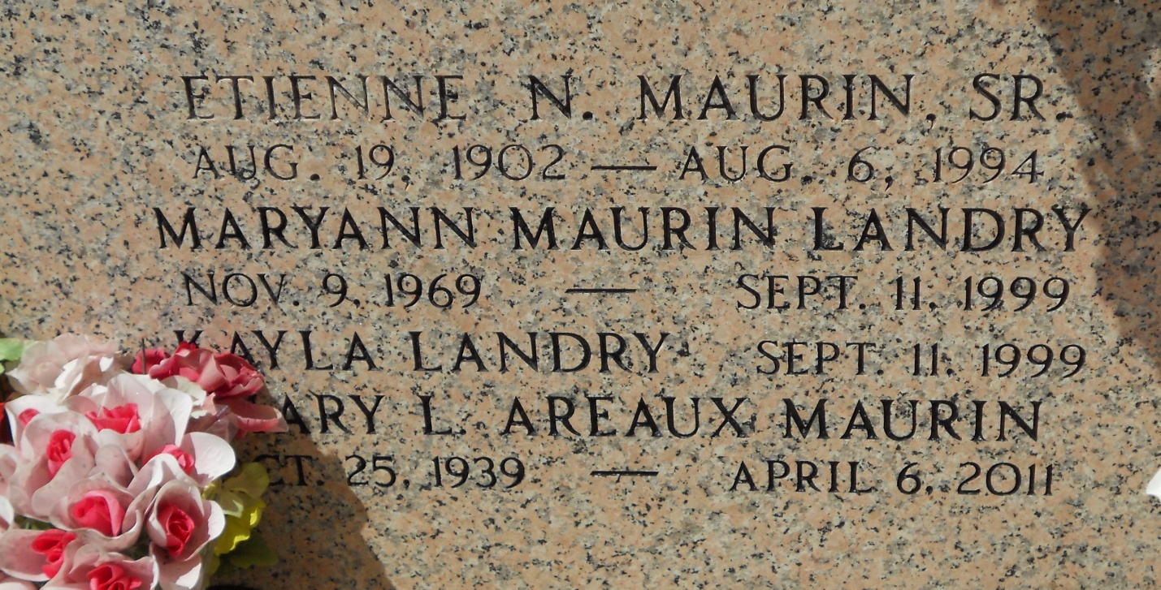
Photo by Team T-Lo

Mary Areaux Maurin passed away on Wednesday, April 6, 2011. Beloved wife of Etienne (Nemour) Maurin. Mother of Jimmy Maurin, Brenda Maurin Granier and the late Mary Ann M. Landry. Also survived by 4 grandchildren. Age 71. A native of New Orleans, LA and a resident of LaPlace, LA.

Relatives and friends are invited to attend services. Visitation at Millet-Guidry Funeral Home, 2806 W. Airline Hwy., LaPlace, LA on Sunday, April 10, 2011 from 5:00 pm to 9:00 pm and on Monday from 8:00 am to 10:30 am, followed by a Mass at Ascension of Our Lord Catholic Church, 1900 Greenwood, LaPlace, LA at 11:00 am. Burial in St. Peter Cemetery, Reserve, LA.

The Times-Picayune, New Orleans, Louisiana
April 10, 2011

