Roland J. Maurin
June 7, 1926 – April 16, 2000

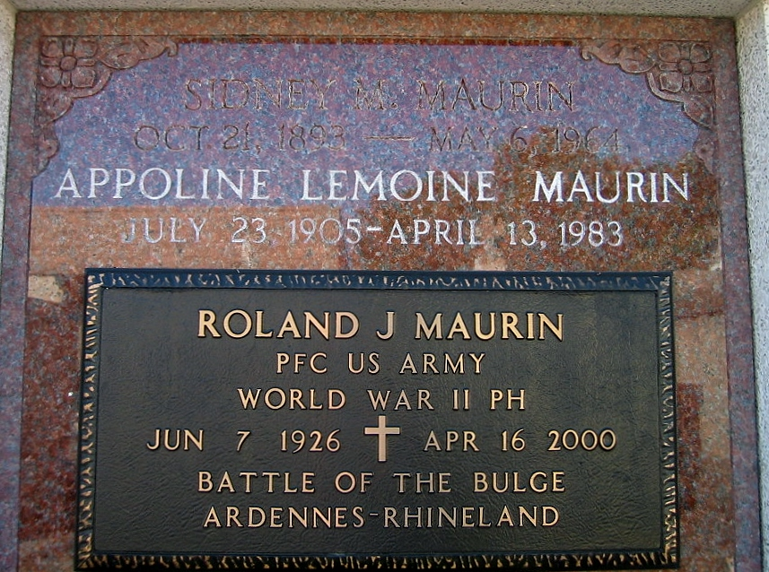
Photo by Bobby

Roland J. "Bolo" Maurin, 73, native and resident of LaPlace, died April 16. He was the husband of Gloria Laiche Maurin and father of R.J., Chris and Caroly Maurin. He was also the son of the late Sidney and Pauline Maurin. He is survived by three grandchildren.

Services are today at 10 a.m. at St. Joan of Arc Church, LaPlace, with interment at St. Peter's Cemetery, Reserve. Visitation begins at 8 a.m.
L'Observateur, LaPlace, Louisiana
April 18, 2000

