Blake Joseph Maus
November 29, 1982 - October 13, 2025

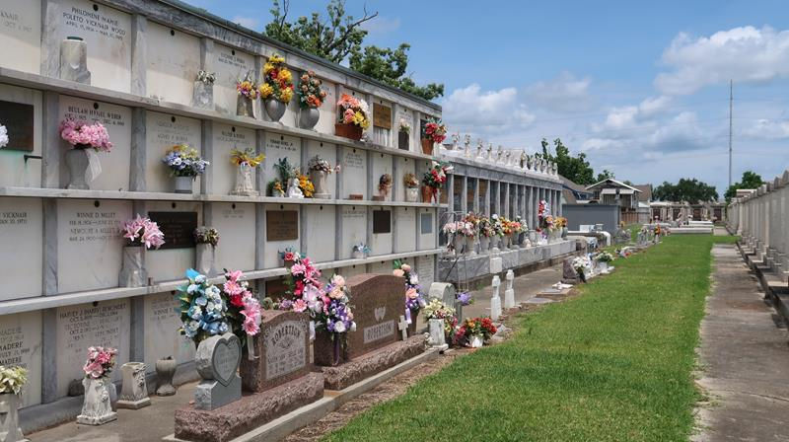

It is with profound sadness and heavy hearts that we announce the passing of Blake Maus, beloved husband, father, son, brother, and friend, who left this world on October 13th, 2025, after a courageous year-long battle with pancreatic cancer. Blake was born on November 29, 1982, and in his 42 years of life, he touched countless hearts with his kindness, loyalty, and unwavering love for his family and community.
Blake is survived by his loving wife, Renee Brouillette Maus, and their two beautiful children, Braiden Maus (12) and Brooklynn Maus (11), who were the light of his life and the center of his world. His legacy lives on through them- in their laughter, their strength, and the love they will carry forward.
Blake was the cherished son of John (Pat) Maus and Darleen Vicknair Maus, and the devoted brother of Brandon Maus (wife Jessica Bourgeois Maus), Jonathan Maus (wife Samantha Kirksey Maus) and chosen sister Ashley Lambert Vicknair (husband Allen Vicknair). He was preceded in death by his dear brother Dustin Maus, whose memory remained close to Blake's heart. He was also a proud godfather to Brennan Maus and Sloane Loupe, and a fun-loving, supportive uncle to his 16 nieces and nephews, all of whom adored him. Blake was surrounded by a large and loving extended family, including five brothers-in-law, seven sisters-in-law, and a multitude of aunts, uncles, and cousins whose support meant everything during his illness.
Blake had a strong work ethic and valued every member of his work family. He was employed by Marathon Petroleum, and previously worked at Bayou Steel and BRS during his youth. He held deep respect and affection for his coworkers, considering them family, and was always proud of the relationships he built throughout his career. During the most difficult days of his life, Blake never gave up hope and never stopped fighting.
We are forever grateful to Dr. Morrison and his compassionate staff, as well as the Interventional Radiology team at East Jefferson, whose care and commitment gave us strength and comfort. The family extends their heartfelt thanks to Perry's Posse, Riverside Academy, Reserve Bantam, and every friend, neighbor, and community member who stood by our side, offering prayers, support, meals, and shoulders to lean on. Your kindness will never be forgotten.
Blake’s life was one of integrity, laughter, and deep love. He will be remembered for his quick wit, gentle spirit, and unwavering devotion to his family. Though our hearts are broken, we take comfort in knowing that Blake is now at peace and will forever watch over us. Blake Maus-a fighter, a friend, a father, and a husband. Gone too soon but loved forever.
A funeral service will be held at St. Peter Catholic Church, Reserve from 9am till 11am with mass to follow at 11:00 am to celebrate Blake’s life and the many ways he made this world a better place. A funeral reception will follow after the final services at the Knights at Columbus Hall 114 W. 7th Street Reserve, LA 70084.

Millet-Guidry Funeral Home, LaPlace, Louisiana

