Henry J. “Pete” Maus
September 16, 1910 – June 28, 1976

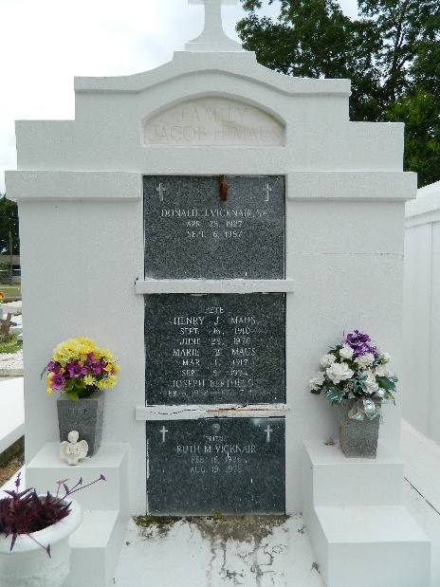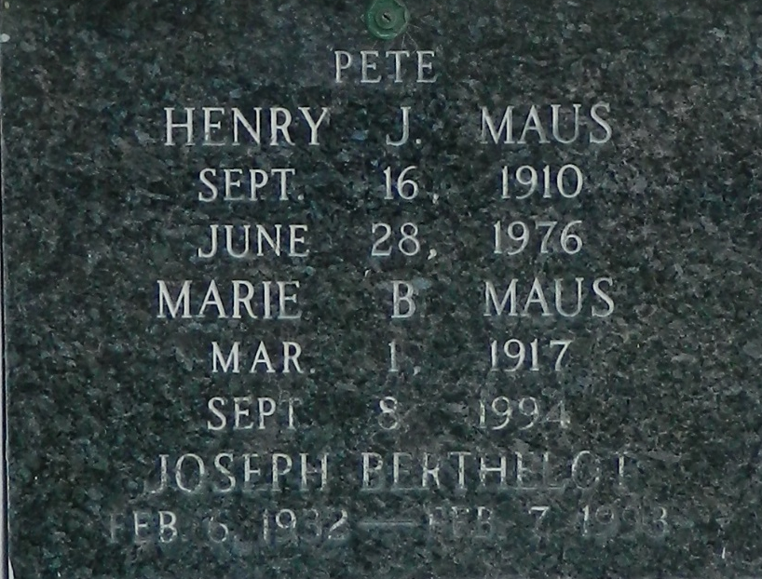

MAUS
Henry (Pete) Maus, on Monday, June 28, 1976 at r:20 a.m., beloved husband of Mrs. Marie Berthelot of Reserve, La., father of Jake and John Patrick Maus, of Reserve, La., and Richard Maus of LaPlace, stepfather of Joseph Berthelot of Reserve, La., survived by 4 grandchildren, son of the late Mr. & Mrs. Jacob Maus, brother of Willow S. Maus and Mrs. Donald Vicknair of Reserve, La., also the late Jake and John Maus and Bertha Williams, age 65 years, a native of Geismar, La., a resident of Reserve for the past 55 years.
Relatives and friends of the family also employees of Godchaux Henderson Sugar Refinery and E. I. Dupont are invited to attend the funeral services. From Millet Funeral Home, Reserve, La., on Tuesday, June 29, 1976 at 10 o’clock a.m. followed by religious services at St. Peter’s Catholic Church. Interment in church cemetery. Friends may call from 5 p.m. to 11 p.m. on Monday, June 28, 1976 and from 8 a.m. until services on Tuesday, June 29, 1976.

Times-Picayune, New Orleans, Louisiana
Tuesday, June 29, 1976, section 1, p. 10

