Arnold Grant McGill
August 27, 1940 - January 20, 2024

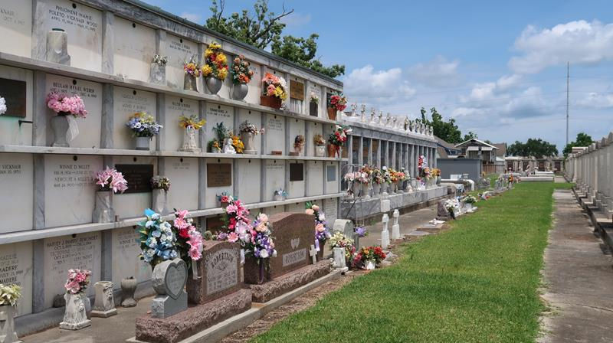

Arnold Grant McGill “Cowboy” passed away on Saturday, January 20, 2024 at the age of 83. He was born in Ashland, MS and was a resident of LaPlace, LA for over the past 50 years where he never met a stranger.
Beloved husband of Paulette Sutton McGill for 49 years. Loving father of Arnold Grant McGill, Jr. (Dena), Kimberly Denise Picou (Tony), Ryan Michael McGill (Lisa) and Nicole Marie Bourgeois (Marc). Son of the late Audrey Irean Wilbanks McGill and James Norton McGill. Brother of Ouida Catherine McGill, Gary Ewart McGill and the late James Marvin McGill, Mary Evelyn Burrows and Neva Sue Brown. Also survived by 15 grandchildren and 5 great grandchildren.
He was proud to share with others that he sang in a Quartet in High School. A multi-sport athlete in high school, Arnold received a full scholarship to play baseball at Northwest Mississippi Jr. College. He was an active 4th degree Member of the Knights of Columbus. He was a proud retiree from Continental Airlines with 43 years of service. What brought him the most joy in this life was spending time with his family and being a proud PawPaw to his grandchildren and great grandchildren.
Relatives and friends are invited to attend the Visitation and Funeral Mass at Ascension of Our Lord Catholic Church, 1900 Greenwood Dr., LaPlace from 9:00 a.m. to 12:00 p.m. followed by a Funeral Mass at 12:00 p.m. Interment in St. Peter Cemetery, Reserve, LA.

Rose Lynn Funeral Home, Lutcher, Louisiana
January 23, 2024

