Dudley Joseph Melancon Sr.
July 3, 1922 – November 22, 2016

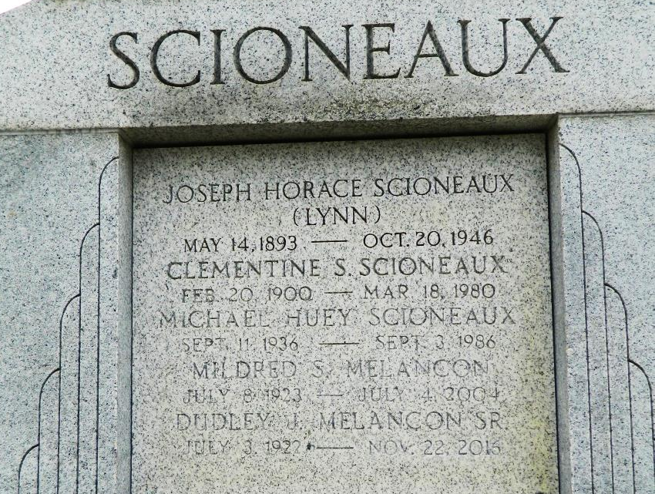

Dudley Joseph Melancon Sr. husband of the late Mildred Scioneaux Melancon passed away on Tuesday, November 22, 2016 at the age of 94 years old. He is survived by his children; Dudley Joseph Melancon Jr. (Mary), Marsha Melancon Mabile (Terry), Dean Jeffery Melancon (Mary), Danny Jude Melancon (Kelly). A proud grandfather of 10 grandchildren: Ava Folse, Anne Stubbs, Abby Melancon (Dutch), Marcy Hopkins (Marsha), Dean Melancon Jr, Kristy Englade (Dean), Jamie Veron, Jolyn Wascom, Jenna Whitmer, Dudley Melancon III (Danny). A great grandfather of 15 great-grandchildren; Alyssa Folse, Alexa Folse, Alana Folse, Amina Davis (Ava), Ashtyn Stubbs (Anne), Dustan Hopkins, Mikah Hopkins (Marcy), Lainey Melancon, Zachary Melancon, (Dean Jr) William Englade, Emma Englade, Ella Englade, Addison Englade (Kristy), Fisher Whitmer (Jenna), Brooklyn Wascom (Jolyn). Son of the late Justine Landry Melancon and George Melancon Jr., brother of Gladys Crower, brother of the late Rita Mae Lambert, Earline Lambert, Velma Keller, Ulysses (Bobby) Melancon, Huey Phillip Melancon Sr., Brother in Law to Joan Scioneaux Brady (John Sr)
A native of Convent Louisiana and a lifelong resident of Reserve Louisiana. "Dutch" Dudley served his country in the United States Army during WWII. After his service in the army he worked for Godchaux Henderson Sugar Refinery for 40+ years until their closing. A member of the St. Peter's Knights of Columbus Council #2436, a member and past post commander of the Reserve American Legion. He enjoyed gardening and volunteering for many church and civic activities. He worked for the registrar of voters at the Lacour Center Precinct in Reserve for 30+ years.
The family would like to extend their thanks to all the staff at the VA Home in Reserve, Louisiana; the doctors, nurses and staff of "Heart of Hospice" New Orleans, Building B, 1700 Belle Chasse Hwy., Gretna Louisiana 70056 for their compassionate care given to "Dudley."
Relatives and friends are invited to attend the visitation on Saturday November 26, 2016 starting at 9:00 am until 11:00 am with a funeral Mass starting at 11:00 am at St. Peter's Catholic Church, 1550 La-44 Reserve Louisiana 70084. Interment will be at St. Peter's Cemetery. Following the burial, a celebration of life will be held at the St. Peter's Knights of Columbus hall located across the street from the church. Food and refreshments will be served. Arrangements by Millet-Guidry Funeral Home. To view or sign the online guest book please visit www.milletguidry.com

Acadiana Advocate, The (Lafayette, Louisiana)
Saturday, November 26, 2016

