Gerald Joseph Melancon
August 28, 1929 – May 10, 2011

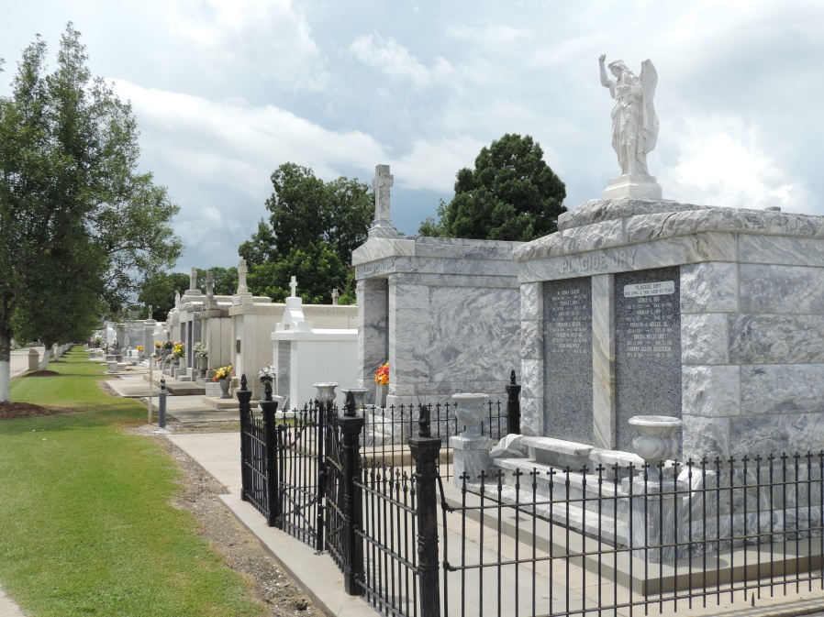

Gerald Joseph Melancon passed away on Tuesday, May 10, 2011. Beloved husband of Eunice Millet Melancon for 61 years. Father of Donna Melancon Crotty Terrio (Danny), Wendell (Nemo) Melancon, Terrell Melancon and Timmy Melancon (Debbie). Father-in-law of the late Duane "Ducie" Crotty. Grandfather of Nathan & Bethany Crotty, Donny Terrio, Ian Melancon, Claire Tarver, Haley, Julie & Wesley Melancon. Great-grandfather of Duane Crotty III. Son of the late Felix and Lucy Louque Melancon. Step-son of the late Stanley Kliebert. Brother of Mary Ann M. Cummins, Ethel M. Roussel Thomas, Francine Kliebert Slimmer & the late Edgard Melancon and Helen M. Kliebert. He was a pillar of strength until his illness. He loved life, was an avid fisherman, hunter and gardner. Founder and owner of Melancon's Home Decorating Center in LaPlace. Age 81. A native of Grand Point, LA and a resident of Garyville for 61 years.
Relatives and friends are invited to attend services. Visitation at Millet-Guidry Funeral Home, 2806 W Airline Hwy., LaPlace, LA, on Friday, May 13, 2011 from 5:00 pm to 9:00 pm and on Saturday at St. Hubert Catholic Church, Garyville from 8:30 am to 10:00 am, followed by Mass at 10:00 am. Burial in St. Peter Cemetery, Reserve, LA.

Times-Picayune, The (New Orleans, LA) - Friday, May 13, 2011
Contributed by Jane Edson

