Frank J. Miano
June 4, 1931 – November 17, 2005

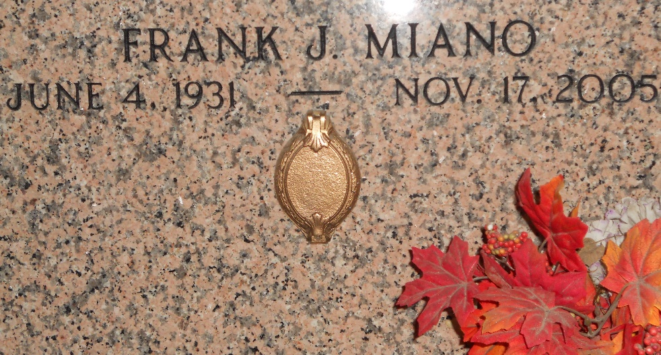
Photo by Team T-Lo

Frank J. Miano, Jr. on Thursday, November 17, 2005 at 11:45 a.m. Beloved husband of the late Connie Weber Miano. Father and father-in-law of Glenn and Toni Miano, Kerry and Peggy Miano, Sandra and Donny Dottolo, Jamie Miano, Allison and E. J. Duhe. Grandfather of: Anne and David Dottolo, Scott, Paul, Jessica, Daniel and Mathew Miano, Ian and Abbie Duhe and Nicole and Angelle Tymon. Great grandfather of: Jordan Dottolo, Jeremy, Josh, Logan and Austin Elrod, and Glenn Paul Miano III. Son of late Frank, Sr. and Mary Miano. Brother of Rosemary Giardina and the late Francis Montelius and Sam and Jake Miano. Age 74 years, a native of Garyville, LA and a resident of Reserve, LA for the past 55 years.
Relatives and friends of the family are invited to attend services. Visitation at St. Peter Catholic Church, Reserve, LA on Saturday, November 19, 2005 from 9:30 a.m. to 12 Noon. Followed by religious services at the church at 12:00 Noon. Burial in Church Cemetery. Arrangements by: Millet-Guidry Funeral Home, LaPlace, LA.

The Times-Picayune, New Orleans, Louisiana
Nov. 19, 2005

