Elaine (Catoire) Miano
January 16, 1934 – February 25, 2009

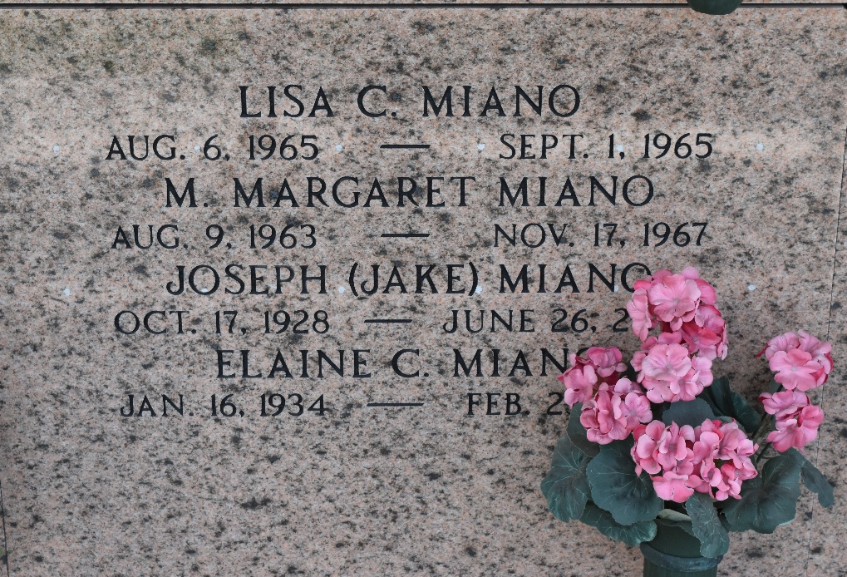

Elaine Catoire Miano on Wednesday, February 25, 2009 at 10:20pm. Beloved wife of the late Joseph (Jake) Miano. Mother of Karen Williams and husband Tim, Marc Miano and wife Susan and the late Margaret and Lisa Miano. Grandmother of Margaret and Reed Williams and Alyssa and Megan Miano. Daughter of the late Guy and Elma Catoire. Sister of Miriam Bannon, Dorrel Catoire and the late Baby Ray and Clyde Catoire. Age 75 years. A native and resident of Reserve, La.
Relatives and friends are invited to attend services. Visitation at Millet-Guidry Funeral Home, 2806 W. Airline Hwy., LaPlace, La., on Saturday, February 28, 2009 from 9:00am to 11:15am. Followed by Religious Services at St. Peter Catholic Church, Reserve, La at 11:30am. Burial in St. Peter Cemetery, Reserve, La.

The Times-Picayune, New Orleans, Louisiana
February 27, 2009

