Gwendolyn (Louque) Miano
January 21, 1943 - February 14, 2021

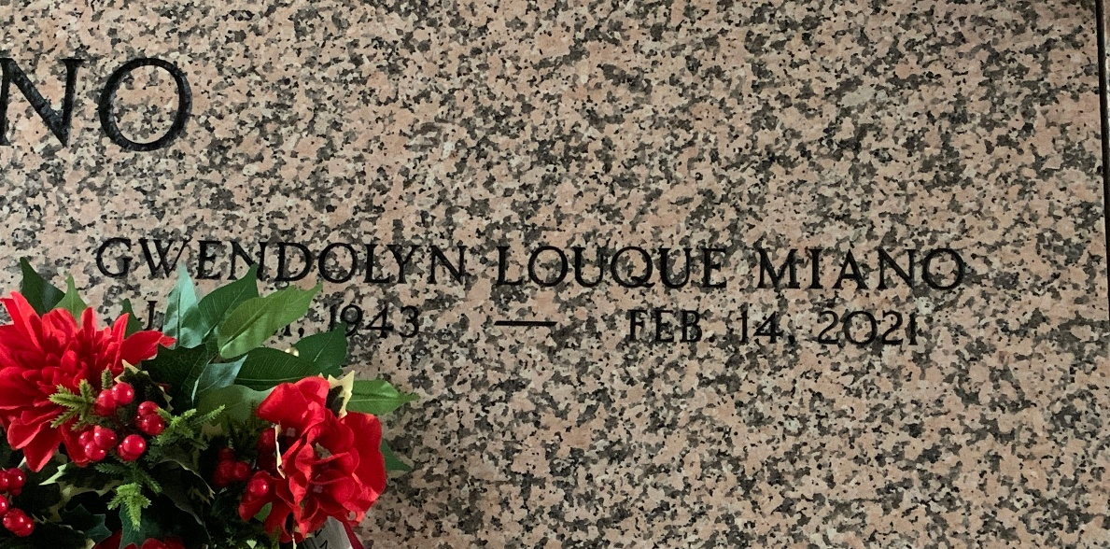
Photo by Team T-Lo

Gwendolyn L. Miano, a native of Gramercy, LA and resident of Garyville, LA, passed away on Sunday, February 14, 2021 at the age of 78. Gwendolyn loved life. She was devoted to God and his catholic family. Her children, grandchildren and great-grandchildren meant the world to her. She enjoyed sewing, cooking for her family, going to the casino and most of all working in her garden.
She is survived by her husband of 61 years, William Miano Jr.; children, Laura Delaneuville, Lisa Savoie, and Vicky Heltz (Chris); grandchildren, Kristin Roccaforte (Mike), Sean Delaneuville (Megan), Heather Irwin (David), Matthew Heltz (Claire), Amanda Decell (Hunter), Donald Savoie III (fiancee, Madison), Jennifer Heltz, and Allison Savoie; great-grandchildren, Brody, Brinley and Brax Roccaforte, Drew and Peyton Irwin, Aubree, Emma and Jace Decell, Madeline, Mason and Baby Heltz, and Noah Delaneuville; siblings, Joan Bourgeois, Pat Trosclair (Lynn), Debbie Waguespack, and Kevin Louque Sr. (Jodie); and sisters-in-law, Linda Miano and Gayle Louque (CJ).
She is preceded in death by her parents, Chester and Ethel Louque; child, Baby Miano; grandchild, Baby Roccaforte; siblings, Lorraine Guidry and Chester Louque Jr.; sister-in-law, Carol Elfer; brothers-in-law, Randall Bourgeois and Warren Waguespack.
A visitation will be held at St. Hubert Catholic Church on Friday, February 19, 2021 from 9:30 am until mass time. A Mass of Christian Burial will begin at 11:00 am. Interment will follow in St. Peter Cemetery.
The family would like to thank Ochsner Medical Center for their care and compassion.

Rose Lynn Funeral Services, Lutcher, Louisiana

