Joseph C. “Jake” Miano
October 17, 1928 – June 26, 2003

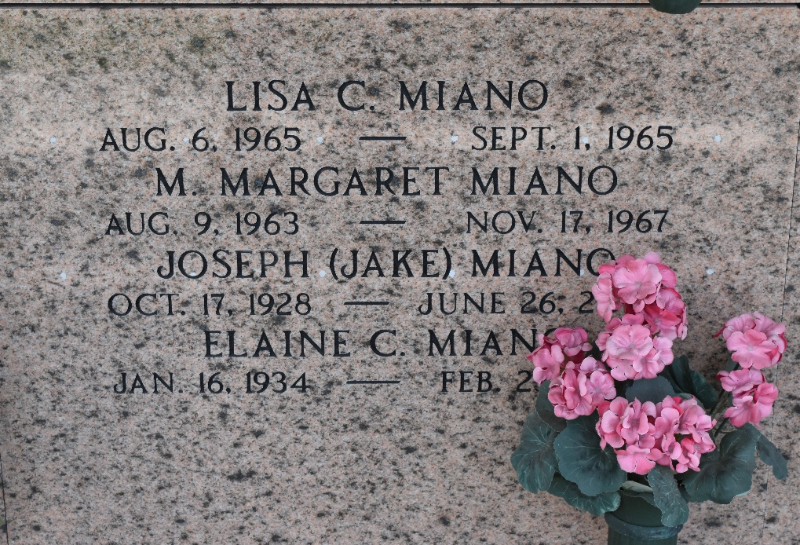

Joseph C. (Jake) Miano on Thursday, June 26, 2003 at 11:15 a.m. Beloved husband of Elaine Catoire Miano. Father of Karen Miano Williams and Marc Miano and the late Margaret and Lisa Miano. Grandfather of Margaret and Reed Williams and Alyssa Miano. Son of the late Frank and Mary Sancetta Miano. Brother of Frank Miano, Jr., Rosemary Miano Giardina and the late Sam F. Miano, and Frances Miano Montelius. Age 74, a native of Garyville and a resident of Reserve for the past 47 years.
Relatives and friends of family are invited to attend services. Visitation at Millet-Guidry Funeral Home, 2806 West Airline Hwy., LaPlace on Sunday, June 29, 2003 from 5:00 p.m. to 10:00 p.m. and on Monday from 8:00 a.m. to 9:45 a.m. Followed by religious services at St. Peter Catholic Church, Reserve at 10:00 a.m. Burial at St. Peter Cemetery.

The Times-Picayune, New Orleans, Louisiana
June 28, 2003

