Leona Mary (Tamplain) Miano
September 28, 1929 – December 24, 2021

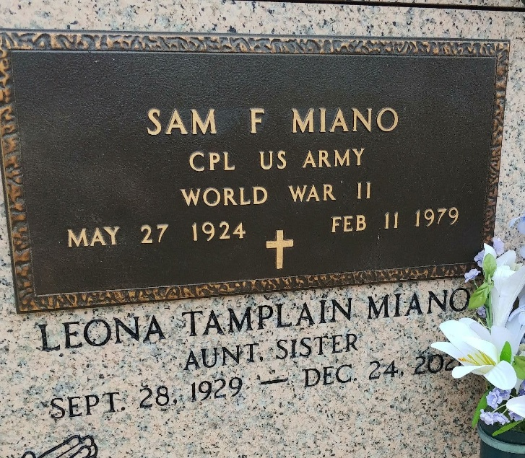
Photo by Team T-Lo

Leona Mary Tamplain Miano, born on September 28, 1929, passed away peacefully Friday, December 24, 2021 with beloved family at her side at the age of 92. She was a lifelong resident of Garyville, LA and a faithful parishioner of St. Hubert Catholic Church, where she served as lector, communion minister and 2nd grade religion teacher for many years. She was a member of the Ladies Auxiliary, Ladies Altar Society, Sisters of the Holy Faith Associates and the 2015 recipient of St. Louis Medallion for devoted service to her church. She retired from St. John Parish School Board as a bus driver.
Leona was the daughter of Wina Robert and Thomas W. Tamplain, Sr.; she was preceded in death by her husband Sam Frank Miano, her eldest daughter Peggy Anne Miano; her brothers, Thomas Tamplain, Jr., Huey Tamplain, David Tamplain, Lionel Tamplain and a sister Carolyn Tamplain Hahn. She is survived by her children, Gordon Miano (Donna), Craig Miano (Linda), Kevin Paul Miano (Noot), Patricia Miano Louque (David), and Kelly Miano Kitners (Tom), siblings Yvonne Tamplain Keating, Harry Tamplain, Robert Tamplain, Sr. and numerous grandchildren, great grandchildren and great great grandchildren.
The family would like to thank No Place Like Home Caregiver Services LLC. Care givers Bonnie Bergeron and Suzanne Hebert for their excellent care in her final days.
Relatives and friends are invited to attend the visitation at St. Hubert Catholic Church, 176 Anthony Monica St., Garyville, LA on Thursday, December 30, from 9:00 a.m. until 11:00 a.m. A Funeral Mass will be celebrated at 11:00 a.m. Interment will follow in St. Peter's Cemetery.
Millet-Guidry Funeral Home, LaPlace, Louisiana
December 28, 2021

