Myrtle Marie (Troxler) Miano
August 6, 1922 – February 11, 2007

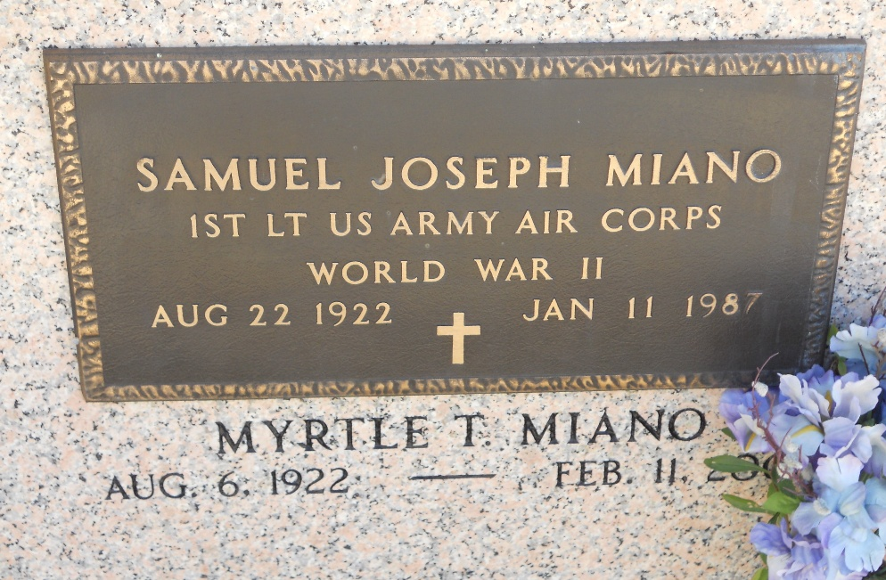
Photo by Team T-Lo

Myrtle Troxler Miano on Sunday, February 11, 2007 at 7:40 AM. Beloved wife of the late Samuel J. Miano. Mother of Kent, Drew and Ross Miano and Greer Millet. Grandmother of Kevin, Amanda, Sam and James Miano and Gracie and Madeline Millet. Age 84 years. A resident of Reserve, LA.

Relatives and friends of the family, and also St. Peter Church Choir are invited to attend services. Visitation at St. Peter Catholic Church, Reserve, LA, on Wednesday, February 14, 2007, from 9:30 AM until 11:30 AM, followed by Religious Services. Burial will be held in the church Cemetery. Arrangements by Millet-Guidry Funeral Home, LaPlace, LA.

Times-Picayune, New Orleans, Louisiana
Feb. 12, 2007

