Samuel Paul “Sammy” Miano Sr.
March 3, 1935 – April 21, 2019

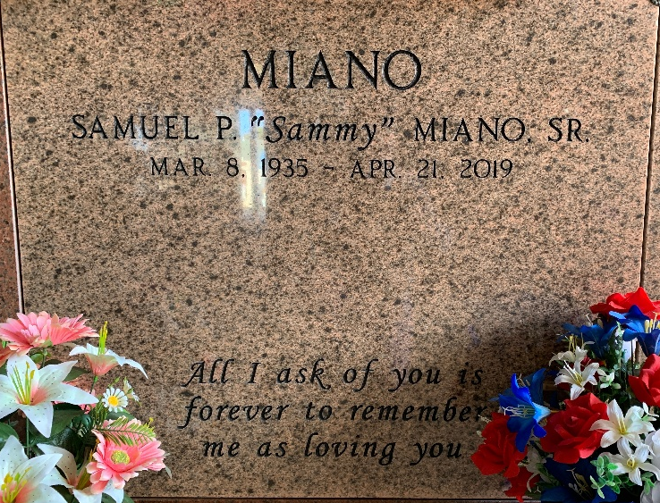
Photo by Team T-Lo

Samuel “Sammy” Paul Miano, Sr. passed away at his residence on Sunday, April 21, 2019 at the age of 84. He was a native and lifelong resident of Garyville. Sammy was a Micropaleontologist for Amoco Production Co. for 32 years (1957 - 1989) in Houston and in New Orleans.
Beloved husband of his beautiful bride, Dorothy Songy Miano, for over 61 years. Loving father of Valerie Miano Gremillion (Michael), Samuel P. Miano, Jr. DDS (Sue), Anne Miano Dupre (David), Paul Miano (Alice) and Pennie Miano Ferrazzano (Giovanni). Grandfather of Christopher Clement (Krissy), Sarah Clement, Kelly Clement, Michael Gremillion, II (Stephanie), Maria Miano Suggs (Spencer), Katie Miano, Michael Gauthier, Michelle Gauthier Stevenson (Andrew), Daniel Dupre, Bonnie Dupre, Sophia Miano, Julianna Miano, Gianna Ferrazzano, Lily Ferrazzano and Miriam Ferrazzano. Great grandfather of Damien, Jacob, Evan and Anna Clement. Son of the late Paul “Paboy” Miano and Anna Tramonte Miano. Brother of the late Frances “Baby” Miano St. Pierre. Also survived by many loving nieces and nephews.
Sammy attended St. Peter School (Class of 1949) and Leon Godchaux High School (Class of 1953) in Reserve. He received his Bachelor of Science in Geology from L.S.U. (Class of 1957). Brother Samuel Miano was an Honorary Life Member of the Msgr. Jean Eyraud Knights of Columbus Council #2436 (Reserve/Garyville). He served the council for over 56 years and was a Past Grand Knight. He was a Past President of St. Hubert Church Holy Name Society. Sammy was Past President of the Society of Economic Paleontologists and Mineralogists and a member of GCAGS (Gulf Coast Association of Geological Societies) and AAPG (American Association of Petroleum Geologists). He was a lector and active member at St. Hubert Church.
Sammy was a member of the Garyville Volunteer Fire Department. He was one of the original radio announcers at WCKW in Garyville. Sammy was a member of the Rebels Band with Gary Breaux, member of the L.S.U. Band (clarinet) and member of the L.S.U. ROTC. Sammy loved Dixieland Jazz, cars, gardening and cutting grass on his riding lawnmower. He also adored his pets, Pup, Whitey, Bullet and Tippy. Sammy was the dependable patriarch of the entire Miano family whom he loved very much. His photographic memory and knowledge of many things helped his family greatly. He will be deeply missed by all who knew and loved him.
Relatives and friends are invited to attend the Funeral Mass at St. Hubert Catholic Church, 176 Anthony F Monica St., Garyville on Wednesday, April 24, 2019 at 12:00 p.m. Visitation will be held in church from 10:00 a.m. to 12:00 p.m. Interment in St. Peter Cemetery. In lieu of flowers please consider mass intentions or a donation in his memory to St. Hubert Church.

Millet-Guidry Funeral Home, LaPlace, Louisiana
April 23, 2019

