Charles Joseph Michel Sr.
November 4, 1924 – June 22, 2012

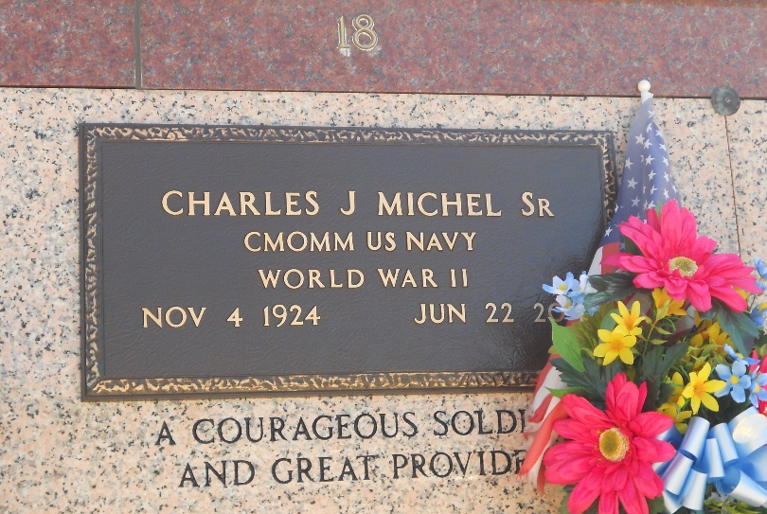
Photo by Team T-Lo

Charles Joseph Michel, Sr. passed away peacefully on Friday, June 22, 2012, at the age of 87, while surrounded by his family. Beloved husband of Marie Claire Duhe Michel for 65 years. Devoted father of C.J. (Vicki), David (Susan), Michael (Ronny), and Kim Case (Tracy.) Proud Paw Paw of 12 grandchildren: Jessica, Jai, Jeremy, Seth, Lindsay, Monique, Geoffrey, Lauren, Elise, Victoria, Danny and Jenny and great-grandchildren: Michael, Matthew, Destiny, Sydney, and Adeline.
He was preceded in death by his parents: Robert and Emily Michel, and siblings: Robert Michel, Jr., Roy Michel, Lydia Michel Becnel, and Rita Michel Woods.
He served in the United States Navy in World War II as a Chief Petty Officer, was Commander of American Legion Post 159, and retired from Kaiser Aluminum. He leaves a legacy of love and commitment to family and friends, and an abundance of cherished memories.
The family would like to thank Dr. Bailey and the staff of River Parishes Hospital for their care and compassion towards the entire family.
Family and friends are invited to attend services. Visitation will be at St. Peter Catholic Church, Reserve, LA on Monday, June 25, 2012 from 9:00 am to 11:00 am, followed by Mass at 11:00 am. Burial in St. Peter Cemetery.
Serving as pall bearers are his grandsons: Jai, Jeremy, Seth, Geoffrey, Danny and his nephew, Larry Duhe. Arrangements are being handled by Millet-Guidry Funeral Home in Laplace.
The Times-Picayune, New Orleans, Louisiana
June 23-25, 2012

