Floyd Joseph Michel Jr.
September 9, 1947 – July 19, 2017

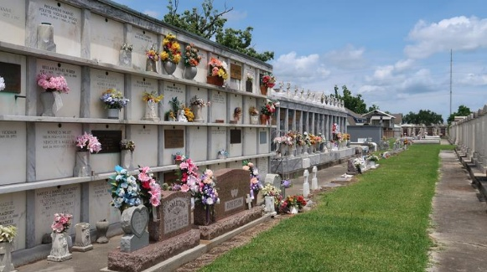

Floyd Joseph “Bosco” Michel, Jr., age 69, passed away at his Reserve, LA home on Wednesday, July 19, 2017, surrounded by his loving family. Floyd was born on September 9, 1947. He was raised in Garyville and a resident of Reserve for the past 47 years. An avid outdoorsman, he enjoyed spending his free time in the swamps of South Louisiana. Floyd had the unique ability to navigate the local waterways with great skill and ease, either by airboat, pirogue, or on foot. He was a successful hunter (deer, alligator, you name it), and his stories of these adventures always made you realize you were in great company with Floyd. He was the president of the Garyville Hunting Club, belonging to it since his childhood. He was a 1965 graduate of Leon Godchaux High School. Following graduation, he enlisted in the United States Marine Corp, serving from 1965-1969. Floyd was a Vietnam Veteran and earned a purple heart for his service. A retiree of IMC Freeport McMoran, Floyd spent his retirement years enjoying his four grandchildren and spending time with family and friends. He was a generous, strong, and hard-working man, always willing to give of himself to others, especially his family. He was a devoted caregiver to his wife, Loma Linda, until her passing in 2016. Floyd enjoyed laughs with many people on both good days and bad days.
Floyd is survived by his daughter Lei Lani Michel Anders and her husband, James Chris Anders; daughter Lacie Lin Michel Bogen and her husband, Alfred Christopher Bogen; and his beloved grandchildren Melody Bogen, Rex Bogen, Amos Bogen, and Jack Anders.
He was preceded in death by his loving wife, Loma Linda Levet Michel, his mother, Hazel Hymel Michel; father, Floyd J. Michel, Sr.; and sister, Lydia Michel Cashio. Floyd is also survived by his sisters Cheryl Keller (Gerald), Merry Gay Vicknair (Carl Sr.), Allison Michel, and his brother Jeffrey Michel, Sr. (Lisa), and a bounty of aunts, uncles, cousins, nieces, and nephews.
The family would like to thank Eva Becnel as well as Ameracare Hospice for their extraordinary help and assistance.
Visitation will be on Monday, July 24, 2017 at St. Peter Catholic Church in Reserve, LA from 9:00 am to 11:00 am followed by a Mass of Christian Burial at 11:00 am. Interment will be at St. Peter Cemetery
Rose Lynn Funeral Home, Lutcher, Louisiana

