Floyd J. Michel Sr.
August 2, 1923 – June 10, 2016

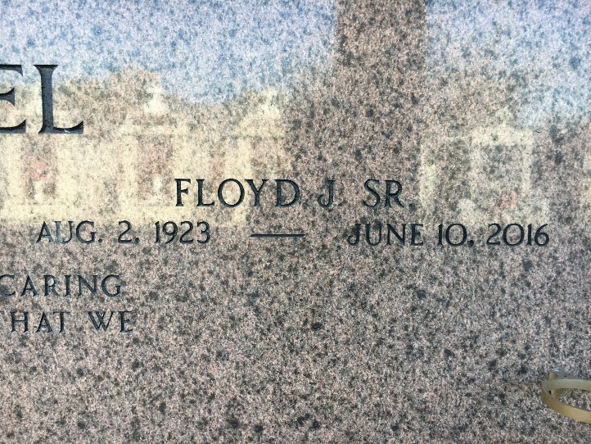
Photo by Team T-Lo

Floyd “Gagoo” Michel, Sr. age 92, went to be with the Lord on June 10, 2016. He is a native of Gramercy, LA and a resident of Garyville, LA. He is survived by his sons: Floyd “Bosco” Michel, Jr. and wife Loma Linda; Jeffrey Michel and wife Lisa; daughters: Cheryl Keller and husband Gerald, Merry Gay Vicknair and husband Carl, and Allison Michel. He is also survived by son-in-law Gary Cashio as well as grandchildren: Lisa Watson, Jerry Keller, Gaylyn Cashio, Holly LeBouef, David Keller, Steven Keller, Lei Lani Anders, Carl Vicknair, Jr., Lacie Lin Bogen, Samy Cashio, Jeffrey Michel, Jr., and Justin Michel. He also leaves behind 23 great-grandchildren and 2 great-great grandchildren.
Floyd loved watching the Saints and LSU games with his beloved wife, as well as dancing. He was an avid hunter, even in his later years of life and loved going to his camp with his sons and grandsons.
He was preceded in death by his wife of 71 years, Hazel Hymel Michel, his parents Jules Michel, Sr. and Alicia St. Pierre Michel; a daughter Lydia Cashio, a grandson Joey Cashio; brothers: Lawrence “Gayan” Michel, Sr., Jules “Te-neg” Michel, Jr. and sisters: Mildred “Mel” Brady and Florence “Bootsy” St. Pierre.
Visitation was on Saturday, June 18, 2016 at St. Hubert Church in Garyville, LA from 8:00 a.m. until 11:00 a.m., followed by a Mass of Christian at 11:00 a.m. Burial followed in St. Peter Cemetery, Reserve, LA In lieu of flowers, donations can be made to the Susan G. Komen Foundation, 6120 Perkins Road, Suite 300, Baton Rouge, LA 70808.
Rose Lynn Funeral Home, Lutcher, Louisiana

