Hazel (Hymel) Michel
November 11, 1924 – November 30, 2015

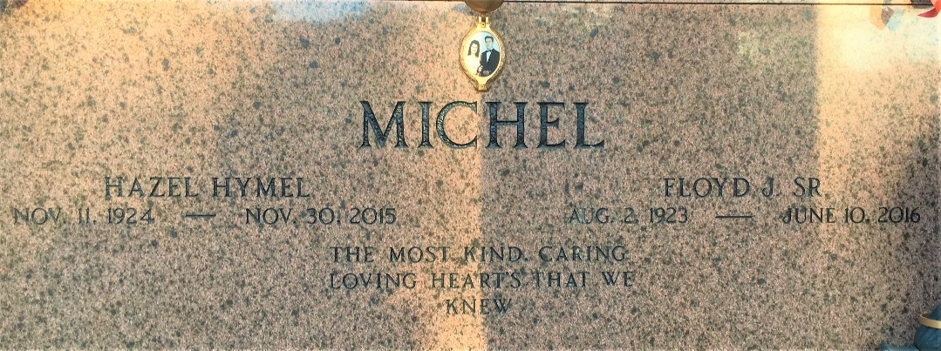
Photo by Team T-Lo

Hazel Hymel Michel, age 91, went to be with the Lord on November 30, 2015. She was a native and resident of Garyville, LA. She is survived by her husband of 71 years, Floyd “Gagoo” Michel, Sr.; her sons: Floyd “Bosco” Michel, Jr. and wife Loma Linda, and Jeffrey Michel and wife Lisa; daughters: Cheryl Keller and husband Gerald, Merry Gay Vicknair and husband Carl, Allison Michel, son-in-law, Gary Cashio; brothers: Clyde, Kermit, Bob, Ken, Tim, and Mike Hymel; sisters: Betty Ramagos, Veronica Aucoin, Cynthia Schaubut, and Linda Haydel as well as her grandchildren: Lisa Watson, Jerry Keller, Gaylyn Cashio, Holly LeBouef, David Keller, Steven Keller, Lei Lani Anders, Carl Vicknair, Jr., Lacie Lin Bogen, Samy Cashio, Jeffrey Michel, Jr., and Justin Michel. She will be greatly missed by her 23 great-grandchildren and 2 great-great grandchildren.
She is preceded in death by her parents: Arthur Hymel and Lydia Plaisance Hymel; daughter, Lydia Cashio; grandson, Joey Cashio; sisters, Gertrude Jacob, and Elmire Vicknair.
Our Mother was a woman of great faith and truly loved her family and friends. She loved bowling and dancing with her grandchildren while watching her favorite show “The Lawrence Welk Show”. She loved writing and reading books and attended Nicholls State University later on in her life where she studied English.
Visitation will be on Saturday, December 5, 2015 at St. Hubert Catholic Church in Garyville, LA from 9:00 a.m. until 11:00 a.m. followed by a Mass of Christian Burial at 11:00 a.m. Interment will follow in St. Peter Cemetery in Reserve, LA.
Rose Lynn Funeral Home, Lutcher, Louisiana

