Loma Linda (Levet) Michel
September 11, 1947 – September 26, 2016

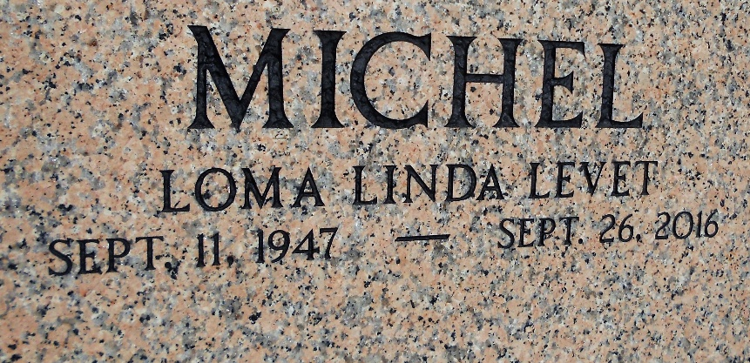
Photo by Team T-Lo

Loma Linda “Lomie” Levet Michel, age 69, passed away at her Reserve, LA home on Monday, September 26, 2016, surrounded by her loving family.
Lomie was born on September 11, 1947. She was a lifelong resident of Reserve, LA, living within one geographic mile her whole life. A dedicated parishioner of St. Peter Catholic Church Parish, she was a 1961 graduate of St. Peter Catholic School. She was also a 1965 graduate of Leon Godchaux High School.
After high school, Lomie worked at Avondale Shipyards for 9 years, waking up at 5:00 am five days a week to commute across the Huey P. Long Bridge with her father. In 1977, she started working at the St. John the Baptist Parish Sheriff’s Office. She was a tried and true employee, retiring after 32 years of service. You may remember seeing Lomie around St. John the Baptist Parish as Rudolph the Red Nosed Reindeer, Polly the Easter Bunny, the Ed-U-Gator Alligator, or a Thanksgiving turkey. However, her most favorite role was as a mother, wife, and daughter. Her smile was radiant and her laughter was infectious.
Lomie is survived by her beloved husband of 45 years (would be 46 years on Halloween), Floyd J. “Bosco” Michel, Jr.; daughter Lei Lani Michel Anders and her husband, James Chris Anders; daughter Lacie Lin Michel Bogen and her husband, Alfred Christopher Bogen; and her beloved grandchildren Melody Bogen, Rex Bogen, Amos Bogen, and Jack Anders.
She was preceded in death by her father, Percy J. Levet and mother, Ruth Montz Levet. Although Lomie was an only child, she is also survived by numerous in-laws, cousins, nieces, and nephews. In honor of Lomie, make sure you share a smile with someone every day.
Visitation will be on Friday, September 30, 2016 at St. Peter Catholic Church in Reserve, LA from 9:00 am to 11:00 am followed by a Mass of Christian Burial at 11:00 am. Burial will be at St. Peter Cemetery.
Rose Lynn Funeral Home, Lutcher, Louisiana

