Marie Claire (Duhe) Michel
August 6, 1928 – July 8, 2012

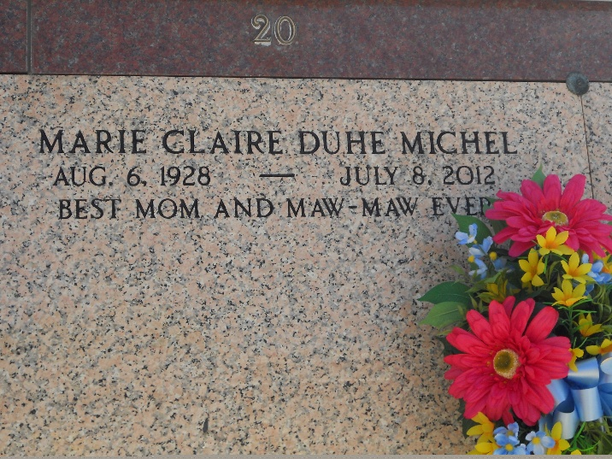
Photo by Team T-Lo

Marie Claire Duhe Michel, 83 years old, passed away on Sunday, July 8, 2012, only 16 days after her husband, Charles Michel, Sr., died. She was the devoted mother of C.J. (Vicki), David (Susan), Michael (Ronny), and Kim Case (Tracy.) She was a loving Maw Maw to her grandchildren: Jessica, Jai, Jeremy, Seth, Lindsay, Monique, Geoffrey, Lauren, Elise, Victoria, Danny and Jenny and great-grandchildren: Michael, Matthew, Destiny, Sydney, and Adeline.
She is preceded in death by her parents Ambrose "Tatoon" and Bernadette Duhe, and siblings Jules, Bernadette D. Oubre, Antoine, Albert, Aline D. Gueret, Jean, and Ann D. Torres. She is survived by siblings Lawrence, James "Poncho," and Errol.
Claire enjoyed caring for all those who were blessed to be in her life, and she made sure visitors to her home never left hungry. She was deeply loved and will be sorely missed by her family and friends.
Serving as pall bearers are her grandsons Jai, Jeremy, Seth, Geoffrey, and Danny, and nephew Larry Duhe.
Family and friends are invited to attend services. Visitation will be at St. Peter Catholic Church, Reserve, LA on Thursday, July 12, 2012 from 9:00 am to 11:00 am, followed by Mass at 11:00 am. Burial in St. Peter Cemetery. Arrangements are being handled by Millet-Guidry Funeral Home.

The Times-Picayune, New Orleans, Louisiana
Jul. 10 to Jul. 12, 2012

