Rene J. Michel Sr.
March 8, 1932 – October 17, 2005

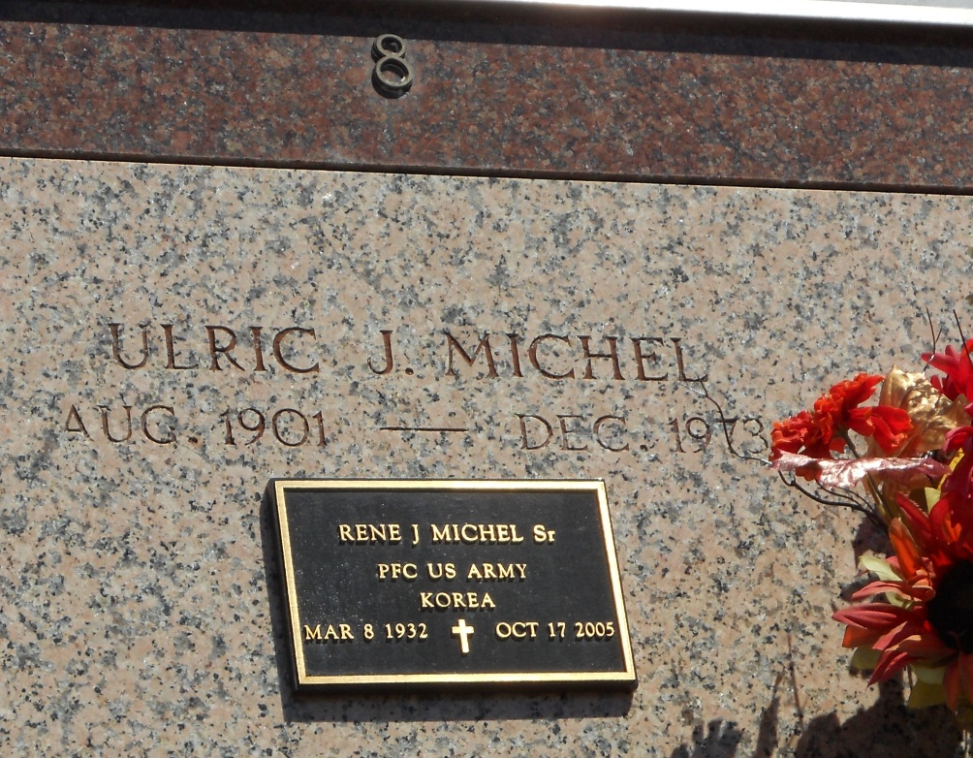
Photo by Team T-Lo

Rene' J. Michel, Sr., at his Westwego, Louisiana residence on Monday, October 17, 2005 at 6:40 A.M. Age 73 years. Husband of the late Bobbie Stewart Michel. Father of Debbie Michel Palazzo, Kathi Michel, Rene' J. Michel Jr., Steven D. Michel, Robert D. Michel and Rex S. Michel. Son of Ulric and Sedonia…

YourFolks.com

