John Milioto
January 23, 1872 – November 13, 1945

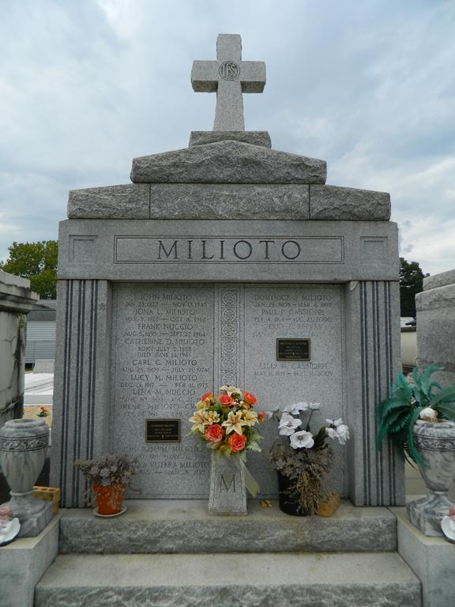

John Milioto died 13 Nov 1945 at age 72 years and 9 months.
Husband of Katherine Depino. Father of Mrs. Frank Nuccio, Dominick, Carl, Joseph, Anthony, Pfc Mike, Rosalie and Lucy Milioto.
Services were 15 Nov 1945 with interment in St Peter Cemetery, Reserve, LA.
The Times-Picayune, New Orleans, Louisiana
November 15, 1945, p. 2

