Lucres (Keller) Milioto
August 25, 1927 - August 21, 2019

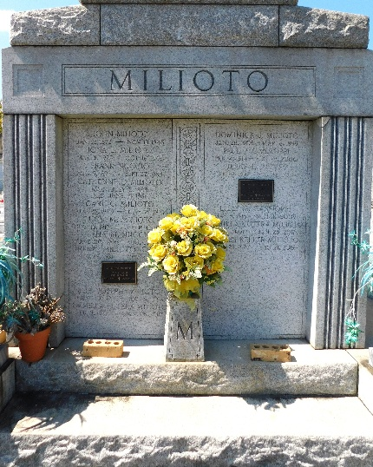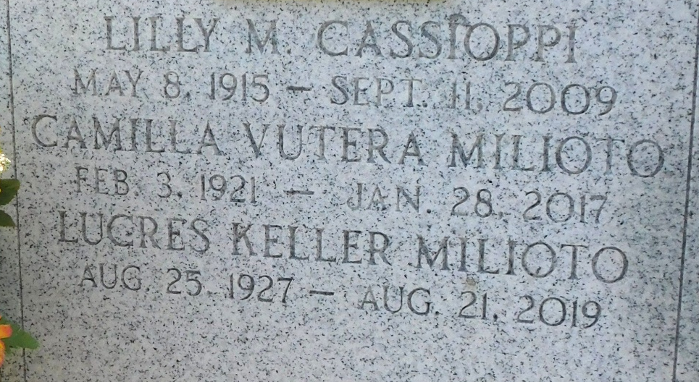
Photo by Mary Agnes Hammett

Lucres Milioto passed away on Wednesday, August 21, 2019 at the age of 91. She was born in Montz, LA and was a resident of LaPlace, LA.
Beloved wife of the late Anthony Milioto. Mother of Eric Milioto (wife, Billie) and Timothy Milioto (wife, Tammy). Grandmother of Erika Reese, Neiman Milioto, Andre Milioto, Jenna Weber and Evan Milioto. Daughter of the late Joliette Jacob Keller and Luke Keller. Sister of Helen Roussel and the late John Keller, Lucille Millet, Gloria Scallan and Anna Mae Tanguis. Also survived by 3 great-grandchildren and many nieces and nephews.
Relatives and friends are invited to attend the Funeral Mass at St. Joan of Arc Catholic Church, 529 W 5th Street, LaPlace, LA on Friday, August 23, 2019 at 11:30 a.m. Visitation at the church from 9:30 a.m. until 11:30 a.m. Interment in St. Peter Cemetery.
Millet-Guidry Funeral Home, LaPlace, Louisiana
Accessed August 22, 2019

