Alfred J. Miller Jr.
September 25, 1914 – February 11, 2003

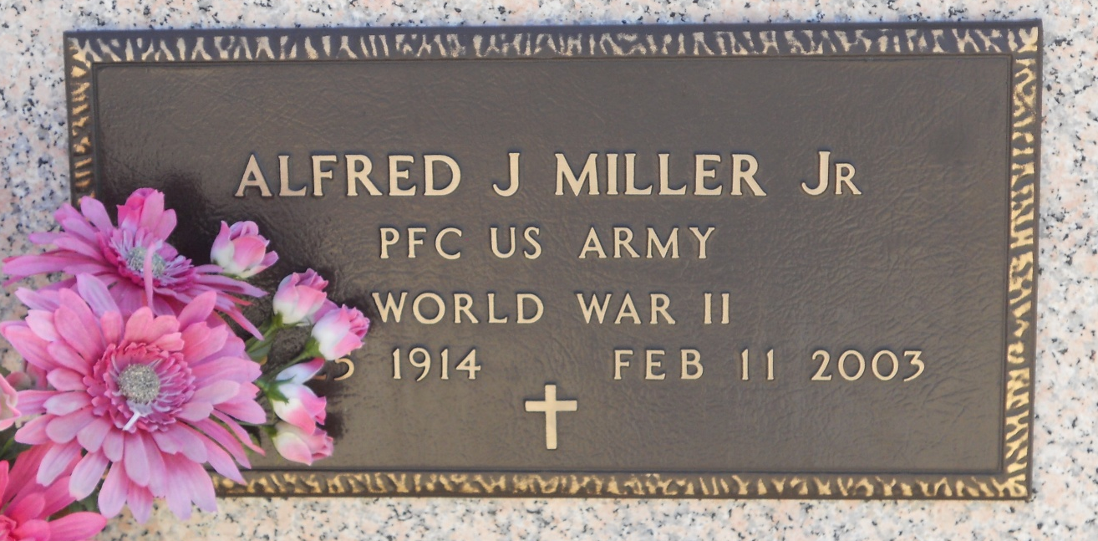
Photo by Team T-Lo
Alfred J Miller, Jr. passed away on Tuesday, February 11, 2003 at his residence in Gramercy. Mr. Miller was a member of V.F.W. Post 5852 of Lutcher, LA; life member of D.A.V. Chapter LA 24 of Reserve, LA; American Legion Post 159 and St. Peter's League of Sacred Heart. He retired from Godcheaux Sugar Refinery in Reserve. Mr. Miller was also a veteran having served in WWII.
Mr. Miller was the husband of the late Eleanor Poche Miller. Son of the late Alfred and Clarise LeBlanc Miller. Brother of George Lois Miller and the late Lillian Miller Braud, Emilie Miller Bourgeois, Lelia Miller Landry, Willie J Miller, Lillie Marie Miller Troxclair and Clarence Miller.
A Mass of Christian Burial will be held Thursday, February 13, 2003 at 10:00 AM at St. Peter's Catholic Church in Reserve, LA. Interment to follow in St. Peter Cemetery.

Times-Picayune, The (New Orleans, Louisiana)
February 12, 2003

