Clarisse (LeBlanc) Miller
February 1, 1885 – July 22, 1973

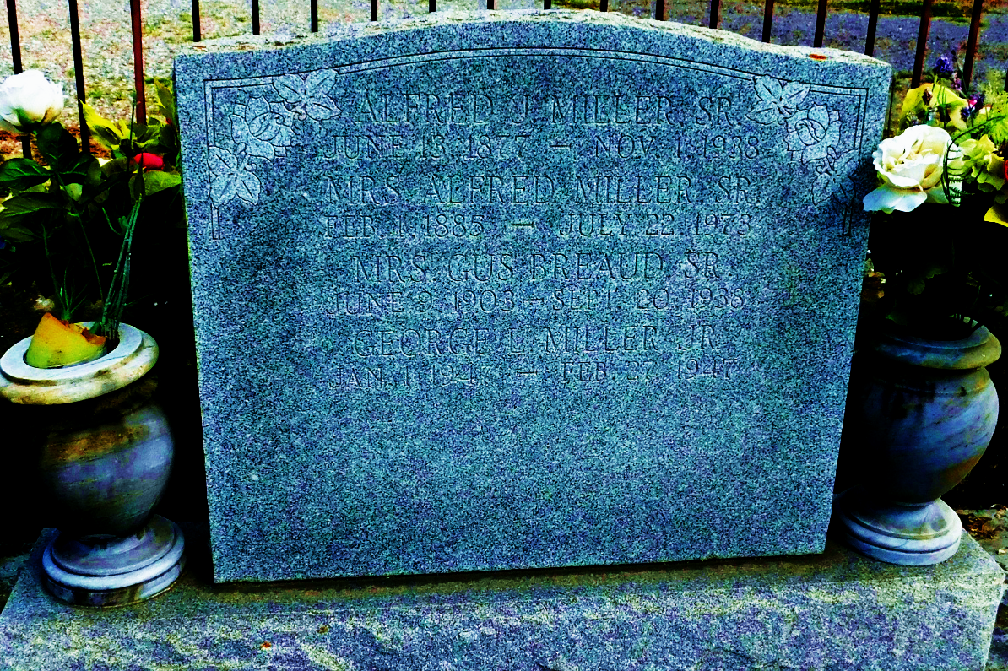
Photo by Mary Agnes Hammett
CLARIS MILLER

Funeral services for Mrs. Claris Miller of Reserve were held at 10:30 a.m., Tuesday, July 24, from St. Peter’s Catholic Church, Reserve.
Mrs. Miller, the former Claris LeBlanc, a native of Grand Point, died at 4 p.m. Sunday, July 22. She was 88 years old.
Her husband, Alfred J. Miller Sr., preceded her in death. She is survived by three sons, Willie, Alfred Jr. and Clarence Miller all of Reserve, and four daughters, Lois Miller, Reserve; Mrs. Didier (Emily) Bourgeois, Gramercy; Mrs. Ernest (Lilly) Trosclair, Lutcher, and Mrs. Louis (Lydia) Landry of Norco.
Twenty-four grandchildren also survive.

L’Observateur, Reserve, Louisiana
Thursday, July 26, 1973, p. 4

