Marie L. (Kilner) Miller
February 11, 1924 – September 18, 2011

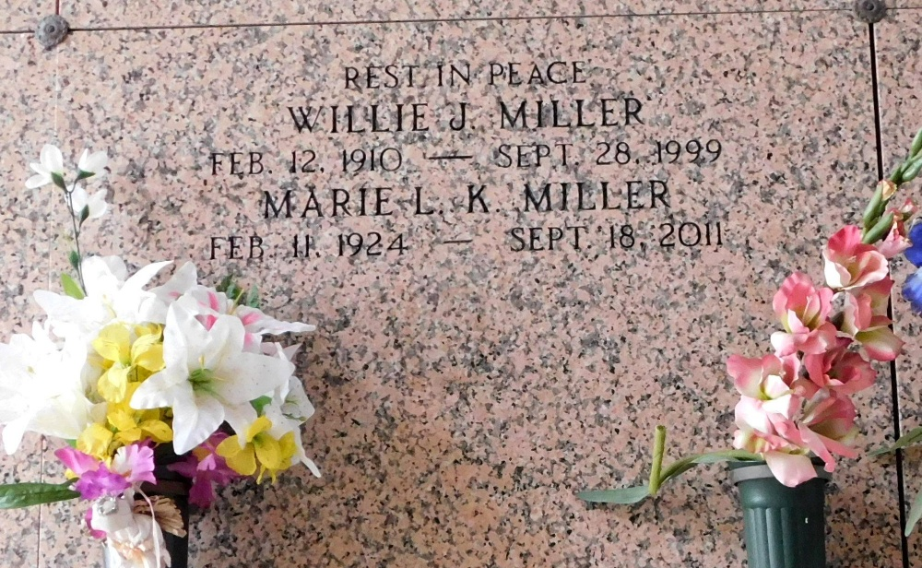
Photo by Mary Agnes Hammett
Marie Kilner Miller passed away on Sunday, September 18, 2011. Beloved wife of the late Willie Miller. Mother of Marie Smith (Phillip), Wilton (Sonny) Miller (Myrtle), Barbara Tamplain (Lionel) and Alice Mollere (Craig). Also survived by 14 grandchildren, 30 great-grandchildren and 4 great-great-grandchildren. Daughter of the late Jimmy and Aline Babin Kilner. Sister of the late Edmond, Henry and Oscar Kilner, Inez Kramer, Noemie Poche, Noelie Vicknair, Theresa Volion and Clarence Poole. Age 87. A native of Paulina, LA and a resident Reserve, LA.
Relatives and friends are invited to attend services. Visitation at Millet-Guidry Funeral Home, 2806 W. Airline Hwy., LaPlace, La. on Thursday, September 22, 2011 from 5:00 pm to 9:00 pm and on Friday from 8:00 am to 9:30 am, followed by Mass at St. Peter Catholic Church, Reserve, LA at 10:00 am. Burial in St. Peter Cemetery, Reserve, LA.

The Times-Picayune, New Orleans, Louisiana
Sep. 20 to Sep. 21, 2011

