Sheldon C. Miller
September 13, 1949 – October 18, 2015

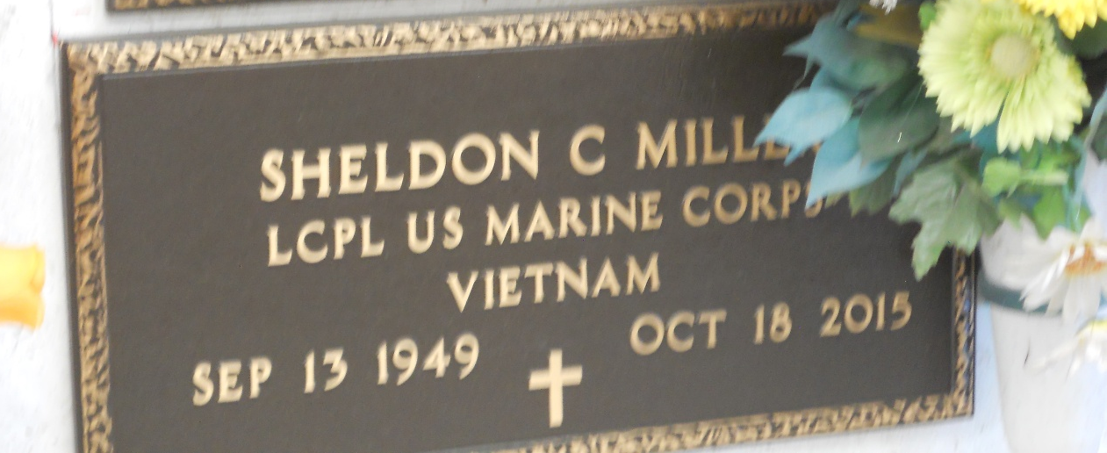
Photo by Team T-Lo
Sheldon C. Miller passed away on October 18, 2015 at the age of 66. He was a native of Reserve and a longtime resident of Maurepas.

He is survived by his brother, Marvin J. Miller (Mary G. Miller).

He was a member of the United States Marine Corps serving in the Vietnam War.

Friends and family are invited to attend a graveside service and burial at St. Peter Cemetery in Reserve, LA on Thursday, November 12, 2015 at 11:00 a.m.

Rose Lynn Funeral Services, Lutcher, Louisiana

