Willie J. Miller
February 10, 1910 – September 28, 1999

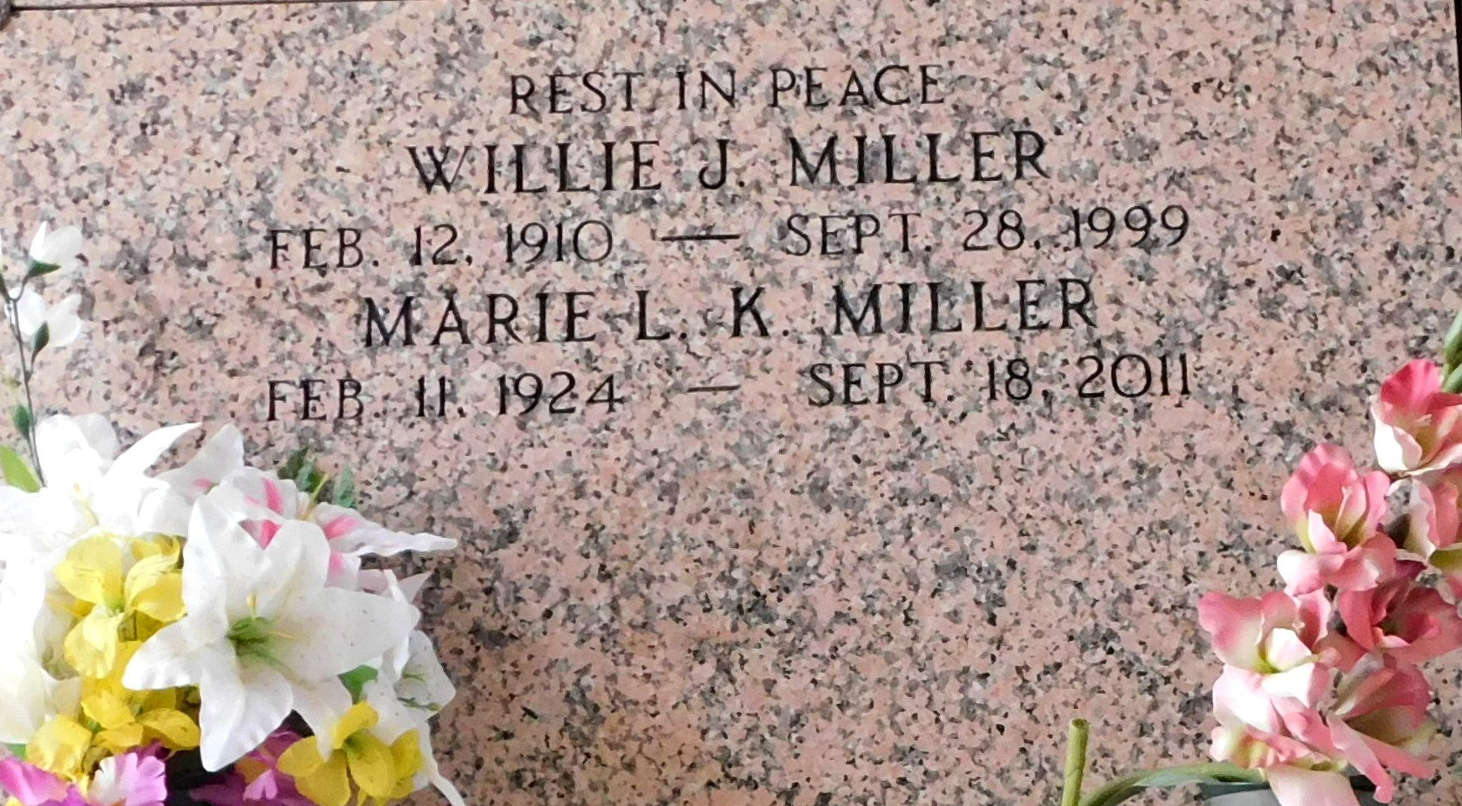
Photo by Mary Agnes Hammett
Willie J. Miller, 89, a native of Convent and a resident of Reserve for 65 years, died Sept. 28, 1999.
He was the husband of Marie Louise Kinler Miller and father of Marie Brownlow, Barbara Tamplain, Alice Mollere and Wilton Miller.
He was also the son of the late Alfred Sr. and Clarice Miller and brother of George Loise and Alfred Miller Jr. and the late Lillie Trosclair, Emily Bourgeois, Lelia Landry, Lillian Bread and Clarence Miller. He is also survived by 14 grandchildren and 24 great-grandchildren.
Services were held Oct. 1, 1999 at St. Peter Catholic Church, Reserve, with interment at the church cemetery.

Unknown source

