Adelard Millet
January 21, 1831 – December 27, 1887

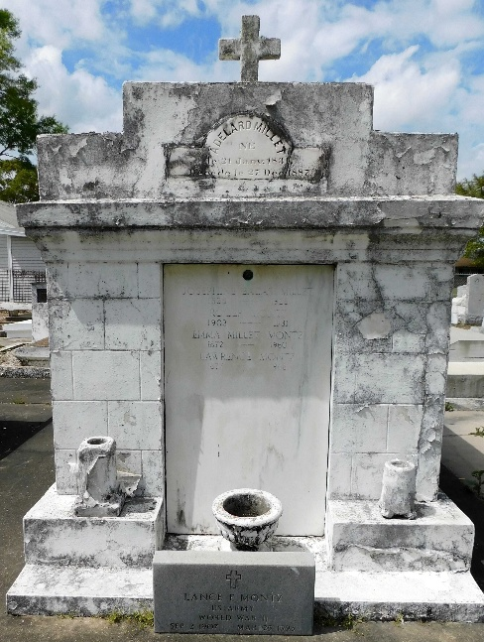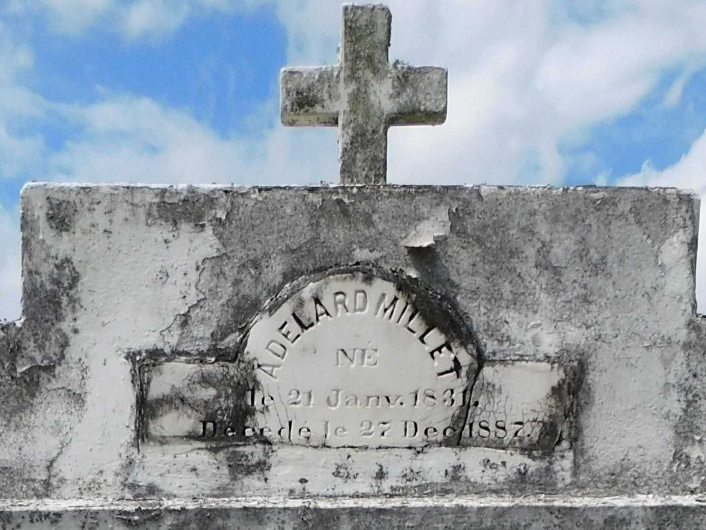
Photo by Mary Agnes Hammett
We regret to announce the death of Mr. Adelard Millet which occurred last Monday night. This worthy citizen, whose condition for several months left little hope to his family and friends, succumbed to one of those diseases against which science has no power. He was about 53 years old and his life was spent working in his home parish. Wednesday a crowd of friends accompanied his body to the cemetery of St Peter.

Le Meschacébé, La Place, Louisiana
31 Dec 1887, p 2

