Antoinette Marie Millet
September 4, 1902 – March 22, 1987

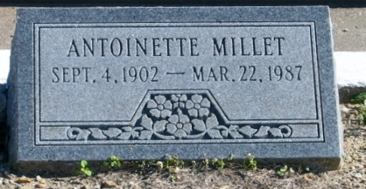
Photo by Bobby

The children loved her. For 48 years, Miss Antoinette M. Millet was the first grade teacher at John L. Ory School in Laplace, Louisiana. Following retirement, she taught first grade for two more years at Riverside Academy in Reserve, Louisiana. She passed away on Sunday, 22 Mar 1987, at the age of 84 following a lengthy illness, but her contributions to her community - especially to the children - will not soon be forgotten.
Her family was further saddened by the death of her brother, Ernest Brice Millet, 80, the same day in Denham Springs, Louisiana, where he made his home. He expired at 2:30 a.m. and she followed at 4:45 p.m.
"Miss Toinette", as she will forever be known, set the small feet of the community's children on the page to the future with intelligent good nature, and earned from those children who passed through her classroom the deep love and respect reserved only for that very first teacher. "The children would just flock to her when they were on the playground", recalls a relative. "She would sit under a shade tree and they would stop playing to go sit with her. That's how much they loved her".
She taught with that single minded dedication of one who holds the trust of parents as well as children. Miss Toinette, a lovely young woman, smiles engagingly from the pages of the 1922 edition of "The Potpourri", yearbook of Louisiana State Normal School in Natchitoches, Louisiana. She never married, but she had many children. Her place is reserved in their hearts for the woman who taught them their ABCs - and respect.
It was ill health that forced her to discontinue teaching in 1972, the year that she celebrated her 50th year of teaching. In June, faculty, family and friends - notable many members of that first 1922 class - gave her a surprise "This Is Your Life" party to celebrate. Miss Toinette was crowned "Queen of Riverside Academy." Members of that 1922 class presented her with a gold medallion. People hid behind a screen for Miss Toinette to guess their identities. There were many who wanted to take part in that. Following the ceremonies, she was feted at a reception given in her honor, attended, among other family members, three of her sisters, May Sicard, Lillian Nobile and Denise Perilloux.
Upon her retirement from the public school system in 1970, she was recognized as Citizen of the Year by LaPlace VFW Post 3337, for her "continuous and untiring devotion to help promote community service".
Miss Millet was a parishioner of St Joan of Arc Catholic Church in LaPlace. She was active in the Ladies Altar Society and Catholic Daughters of America for many years.
A Mass of Christian Burial was held at St Joan of Arc Church in LaPlace, with interment in St Peter's Cemetery, Reserve.
Miss Millet was the daughter of the late Noe Brice Millet and Noelie Dufresne Millet. She is survived by three sisters, Mrs. Wallace (May) Sicard and Mrs. Andrew (Annabel) Stein, both of LaPlace, and Mrs. Lillian Nobile of Lutcher, Louisiana. Another sister, Denise M Perilloux, preceded her in death. Seventy-six nieces and nephews also survive.

L'Observateur, Laplace, Louisiana
2 Apr 1987

