Audrey Louise (Wempren) Millet
March 12, 1922 – May 29, 2008

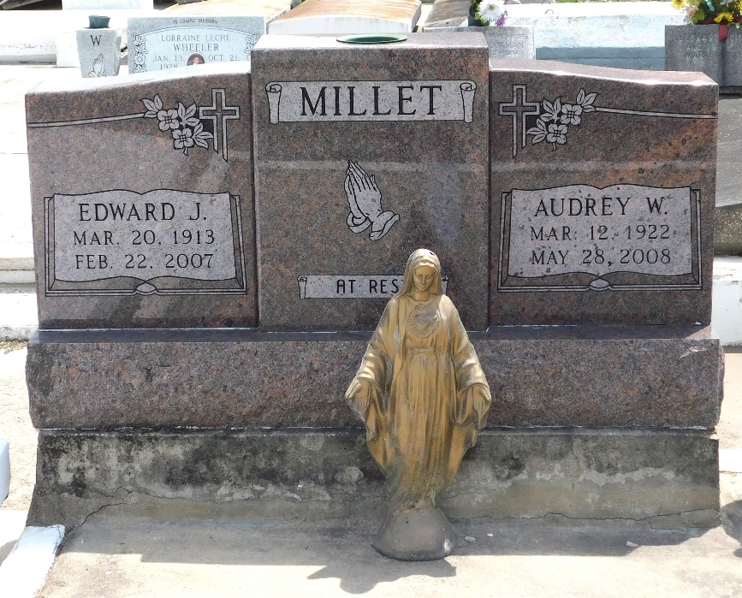
Photo by Mary Agnes Hammett

Audrey Wempren Millet left this world to be with Jesus on Wednesday, May 28, 2008 at 5:30 p.m.

Wife of the late Edward J. Millet. Mother and mother-in-law of Kirt and Mae Mae Millet, Catherine M. and Quill Barbier and Dolly M. Pike and her late husband, Ron. Also survived by 7 grandchildren and 3 great-grandchildren.

Daughter of the late Honore and Alexina Root Wempren. Sister of the late Sonny, Bill and Roy Wempren. Age 86 years. A native and resident of LaPlace, LA.
New Orleans Times Picayune (Louisiana)
May 30, 2008

