Barbara Ann (Vicknair) Millet
August 2, 1940 – July 14, 2017

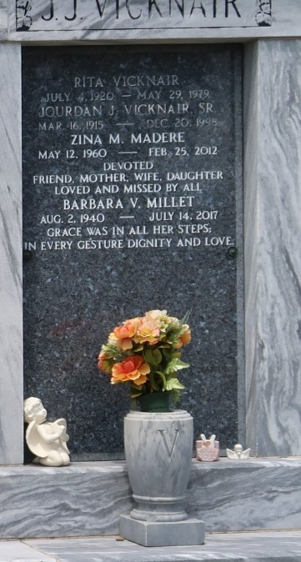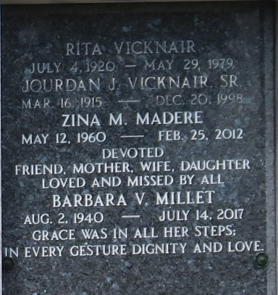

Barbara Vicknair Millet passed away at her residence on Friday, July 14, 2017, at the age of 76. She was a native of Reserve and a resident of LaPlace.
She was the beloved mother of Daniel Millet Jr. and the late Zina Millet Madere; grandmother of Blaine Madere, Harmonie Marks, Justin Millet and Angel Tanner; great grandmother of Tyler and Preston Marks, Kaylee Toleos, Reagan and Rowyn Madere, Hailee Kennedy, and Elise, Ian and London Tanner.
She is the daughter of the late Jourdan J. Vicknair and Rita Vicknair; and sister of Elaine Cortez, Judy Methvin and the late J.J. Vicknair and Wayne Vicknair.
Relatives and friends are invited to attend the visitation at St. Joan of Arc Catholic Church, 529 W. 5th St. in LaPlace on Wednesday, July 19 from 10 a.m. until noon, with the Funeral Mass to follow at noon. Interment is in St. Peter Cemetery.

L’Observateur, LaPlace, Louisiana
Monday, October 2, 2017

