Brice Noe Millet
February 28, 1873 – August 9, 1950

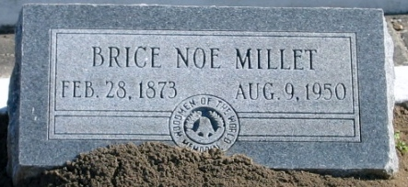
Photo by Bobby
MILLET - At Laplace, La, on Wednesday, August 9, 1950 at 6:00 a.m., BRICE NOE MILLET, husband of the late Noelie Dufresne; father of Mrs. Denise M. Perilloux, Mrs. May Tregre, Mrs. Annabel Stein, and Antoinette Millet of Laplace, La, Mrs. John A. Nobile of Lutcher, La, and Ernest Millet of Denham Springs, La, aged 77 years.

Relatives and friends of the family, also John A Reine, Camp No 504, Woodmen of the World, Laplace, La, are respectfully invited to attend the funeral, which will take place from the Millet Funeral Home, Reserve, La, on Thursday, August 10, 1950, at 3:30 o'clock p.m. Religious services at St Joan of Arc church, Laplace, La, at 4 p.m. Interment in St Peter's cemetery, Reserve, La.

The Times-Picayune, New Orleans, Louisiana
10 Aug 1950, p. 3

