David Wesley Millet
October 4, 1931 – May 3, 2021

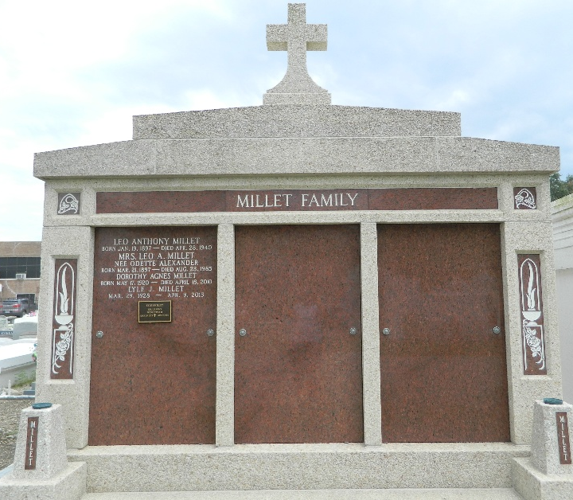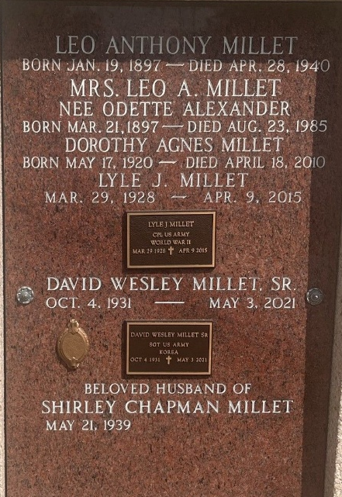

David Wesley Millet, born in Garyville, Louisiana passed away peacefully at his home in Reserve, Louisiana on Monday, May 3, 2021, at the age of 89 years. Beloved husband of 62 years to Shirley Chapman Millet. Loving father to David Jr (Monette Romair Millet), Richard, and John Millet.
Grandfather to Mackenzie Millet Meibaum (John), Olivia Millet Loupe (Zachary), Sophia, Chloe', Austyn, and David Wesley Millet, III. Great-Grandfather to Theo Michael Loupe and John Peter Meibaum.
Survived by sisters Barbara Millet (Norris), Carol Millet Vicknair (late Nolan), Gwendolyn Millet Lemonier (Donald), his brother Jean Millet (Glenda), and many nieces and nephews.
Preceded in death by his parents, Leo and Odette Alexander Millet, brothers Leo Jr, Roland, and Lyle, and sisters Dorothy Millet, Jacqueline Millet Kern, and Minnette Millet Montegut.
Dave was a graduate of Leon Godchaux High School and Southwestern Louisiana University . After his service in the United States Army, he worked as an Industrial Arts teacher and later became a long time insurance agent in the River Parishes and surrounding areas. He was a member of St. Peter's Catholic Church where he served as a Eucharistic Minister. He spent many hours supporting various organizations including: Veterans of Foreign Wars, Knights of Columbus, The St John Business Association, and was a Commissioner for Port of South Louisiana. Dave embodied a strong zeal and determination to work hard, contribute to his community, and make each day better than the one before. Many interests and investments enriched his life but his greatest joy was his love for God, his family, and his friends.
Visitation from 10:00 a.m. to 11:30 a.m., followed by a Mass of Christian Burial beginning at 12:00 p.m. at St. Peter's Catholic Church, 1550 Hwy 44, Reserve, Louisiana on Wednesday, May 19, 2021. Interment in St. Peter Cemetery.
Millet-Guidry Funeral Home, LaPlace, Louisiana

