Dennis E. Millet
November 27, 1916 – September 26, 2010

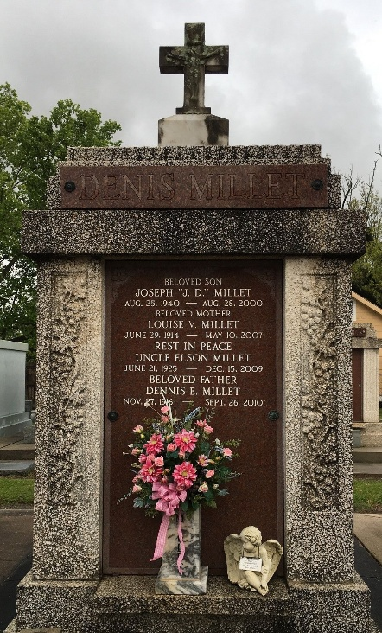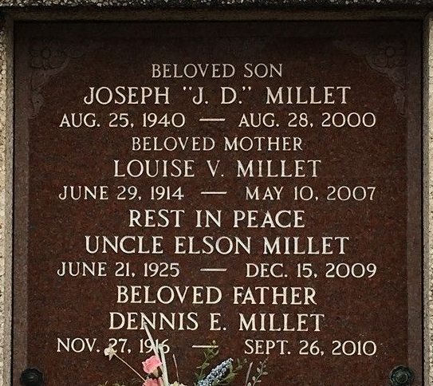

Dennis Millet passed away on Sunday, September 26, 2010. Beloved husband of the late Louise Vicknair Millet. Father of Clarence Millet and wife Lona and the late Joseph (J.D.) Millet. Grandfather of Dennis Millet and wife Jeannie and Robert Tyler Millet and fiancé Carla Parker.
Son of the late Sam and Corinne Millet. Brother of Sammy Millet, Lucille Barthel and the late Earl (Mac), Elson, Irving, Raymond and Norman Millet, Velma Jacob and Edna Miano. He will be sadly missed by nieces and nephews.
He owned and operated the Godchaux Refinery Bus Line, Millet Wholesale, LaPlace and Reserve Minute Mart and Eight Ball Game Room and Washateria. He was an avid L.S.U. Tiger and Saints fan. He had a passion for hunting with his Beagles. In his younger years he enjoyed traveling with his wife and grandsons.
Special thanks to Hospice In Care and caregiver Carla Parker. Age 93. A native of Lions, La. and a resident of Reserve, La.
Relatives and friends are invited to attend services. Visitation at St. Peter Catholic Church, Reserve, La. on Wednesday September 29, 2010 from 9:00 AM to 11:00 AM. Followed by Mass at 11:00 AM. Burial in St. Peter Cemetery. Arrangements by Millet-Guidry Funeral Home, LaPlace, La.

The Times-Picayune, New Orleans, Louisiana
Sep. 28 to Sep. 29, 2010

