Dorothy Agnes Millet
May 17, 1920 – April 18, 2010

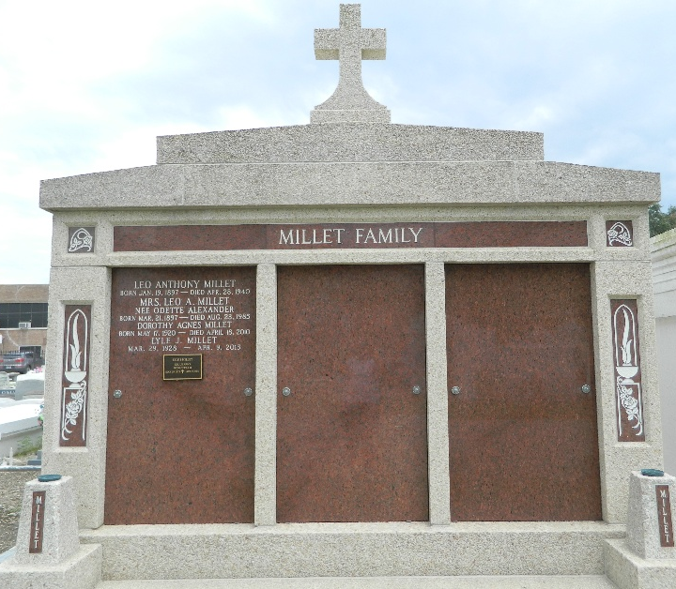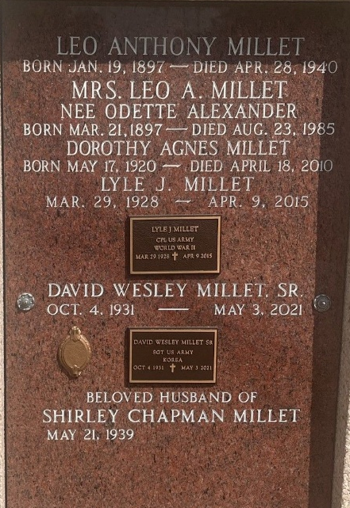

Dorothy Agnes (Dottie) Millet entered into eternal rest at 4:30 p.m., Sunday, April 18, 2010 at Twin Oaks Nursing Home in LaPlace. She was 89 years old and a lifelong resident of Garyville, Louisiana. She retired from Gulf Oil Company in 1970. She also was employed by the St. John the Baptist Parish Council on Aging and was a volunteer at River Parishes Hospital for many years.
Ms. Millet was preceded in death by her parents, Odette Alexander Millet and Leo Anthony Millet, and her brother, Leo A. Millet. Survivors include her sisters, Jacqueline Kern of Slidell, Minnette Montegut and Barbara Millet, both of LaPlace, Carol Vicknair of Madisonville, and Gwen Lemonier of New Orleans; and brothers, Roland Millet and Lyle Millet, both of Garyville, David Millet of Reserve, and Jean Millet of Covington. She also is survived by 28 beloved nieces and nephews.
Dottie loved hosting family gatherings at the Millet home on River Road in Garyville and being surrounded by all of the grandchildren.
Relatives and friends of the family are invited to attend a Funeral Mass at 11 a.m., Wednesday, April 21, 2010 at St. Hubert Catholic Church in Garyville. Internment will be at St. Peter's Cemetery in Reserve. Prior to the funeral, visitation will take place from 9 a.m. until 11 a.m. at St. Hubert's Church. Arrangements by Millet-Guidry Funeral Home in LaPlace.

The Times-Picayune, New Orleans, Louisiana
Apr. 20, 2010

