Earl J. Millet
July 3, 1931 – November 13, 2006

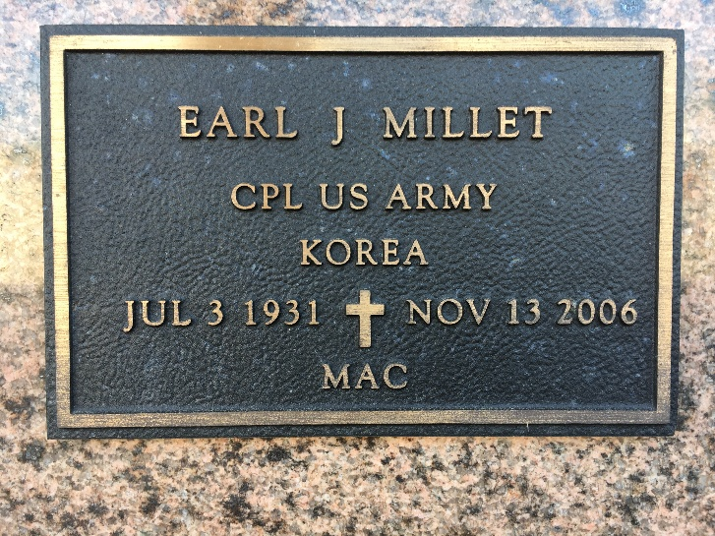
Photo by Team T-Lo

Earl (Mac) Millet, on Monday, November 13, 2006 at 12:10 p.m. Beloved husband of Marie Hebert Millet. Father and father-in-law of Earl, Jr. and Lisa Millet. Grandfather of Brandi and Marci Millet.
Son of the late Sam and Corinne Millet. Brother of Dennis, Elson and Sammy Millet, Velma Jacob, Lucille Barthel and the late Irving, Raymond and Norman Millet and Edna Miano.
He was the owner of Mac's Grill in Reserve. Age 75. A native of Lions, LA. and a resident of Reserve.
Relatives and friends of the family, are invited to attend services. Visitation at St. Peter Catholic Church, Reserve, LA. on Wednesday, November 15, from 10 a.m. to 1 p.m. followed by religious services at the church at 1 p.m. Burial in church cemetery. Arrangements by Millet-Guidry Funeral Home, Laplace.

The Times-Picayune, New Orleans, Louisiana
November 14, 2006

