Edward Joseph Millet
March 20, 1913 – February 22, 2007

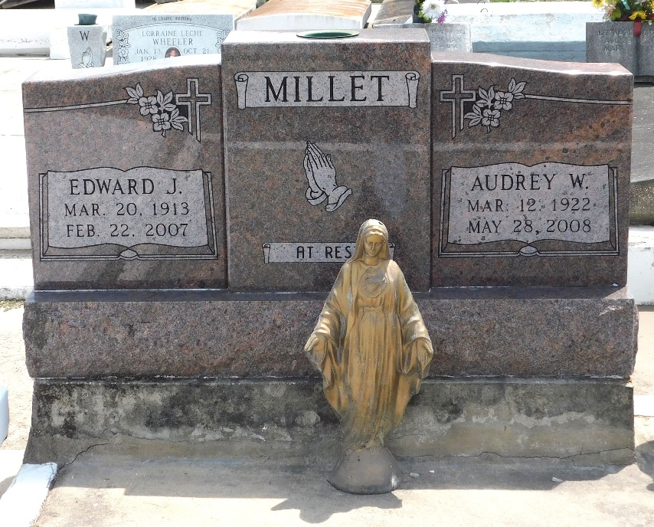
Photo by Mary Agnes Hammett

Edward J. Millet on Thursday February 22, 2007 at 6:00p.m.

Husband of Audrey Wempren Millet. Father and Father-in-law of Kirt and Mae Mae Millet, Catherine M. and Quill Barbier and Dolly M. Pike. Also survived by 7 grandchildren and 3 great-grandchildren.

Son of the late Edward and Oceania Vicknair Millet. Brother of Edna LeBlanc, Aline Beal and the late Virginia Cuny, Ida Mae Madere and Allen Millet.

Age 93. A native of Montz, LA. and a resident of LaPlace, LA.
New Orleans Times Picayune (LA)
February 24, 2007

