Elmore Joseph Millet Sr.
June 5, 1902 – April 10, 1933

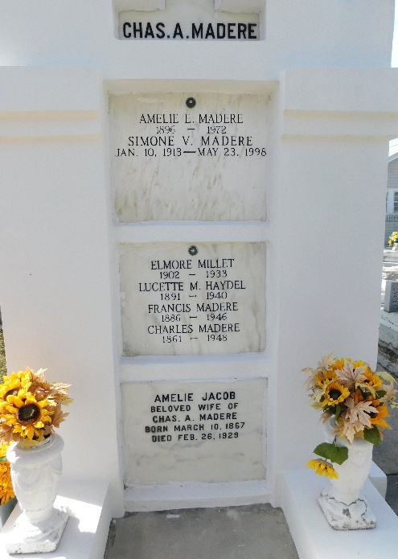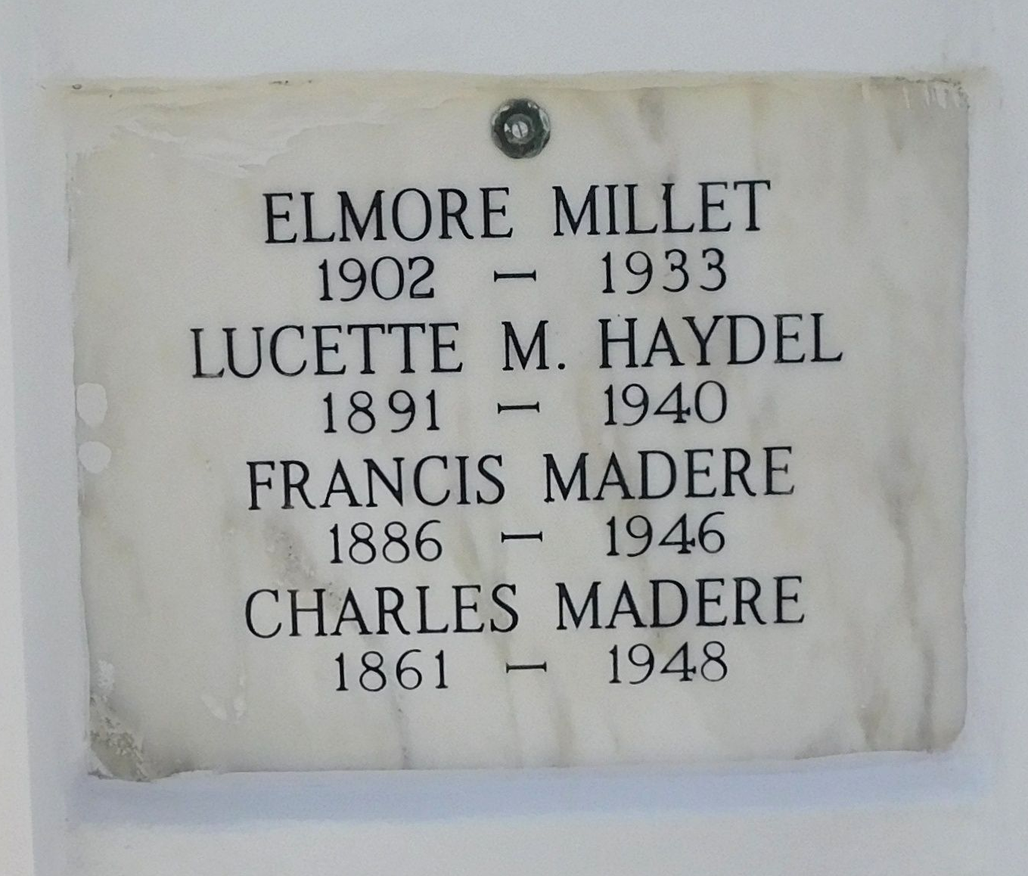
Photo by Mary Agnes Hammett

Elmore J. Millet died at Norco, Louisiana, on Monday 10 Apr 1933 at 6:35 o'clock a.m. He was the husband of Adele Madere and father of E. J. Jr. and Iris Millet. He was the son of Seraphin Millet and Clotilde Lasseigne and the brother of Edward, Sidney, Levy and Nemour Millet, Mrs. Robert Montz and Mrs. Joseph S. Perilloux. Age 30 years and 10 months.

The relatives and friends of the family, also the employees of the Shell Petroleum Corporation of Norco, Louisiana, are invited to attend the funeral on Tuesday 11 Apr 1933 from the funeral home of Jules Millet, Reserve, Louisiana, with services at St Peter's Church, Reserve. Interment in St Peter Cemetery, Reserve.
The Times-Picayune, New Orleans, Louisiana
11 Apr 1933, p 2

