Emeline (Duhe) Millet
November 19, 1897 – July 27, 1979
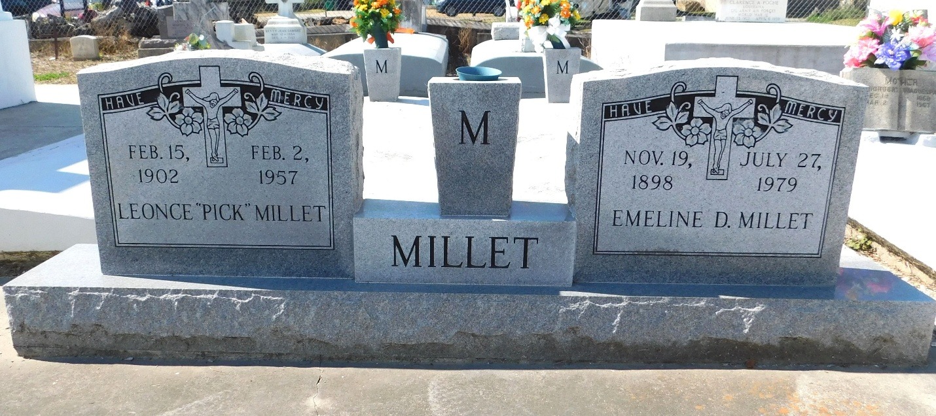
Photo by Mary Agnes Hammett

MILLET, EMELINE D.
Died at 5 p.m. Friday, July 27, 1979, at St James Hospital, Lutcher. She was 81, a native and resident of Garyville.
Wake services from 5 to 11 p.m. Sunday at Millet Funeral Home, Reserve. Religious services at St Hubert Catholic Church, Garyville, at 10:30 a.m. Monday. Burial in St Peter Cemetery.
Survived by four sons, Leonce A., Arthur, J. C., and Robert Millet; eight daughters, Louise LeMoine, Florence Porta, Helen Brady, Eunice Melancon, Doris Louque, Audre St Pierre, Lavonne Brady and Ferrell Ann Chauvin; three brothers, Raymond, Paul and A. J. Duhe; a sister, Mrs. Claude Montz; 41 grandchildren and 32 great grandchildren.
Preceded in death by her husband, Leonce J Millet, and five brothers, Louis, Mederick, Roland, Mack and Johnny Duhe.
The Advocate, Baton Rouge, Louisiana
29 Jul 1979, p 4-B

