Felix Henry Millet
January 5, 1873 - June 15, 1951

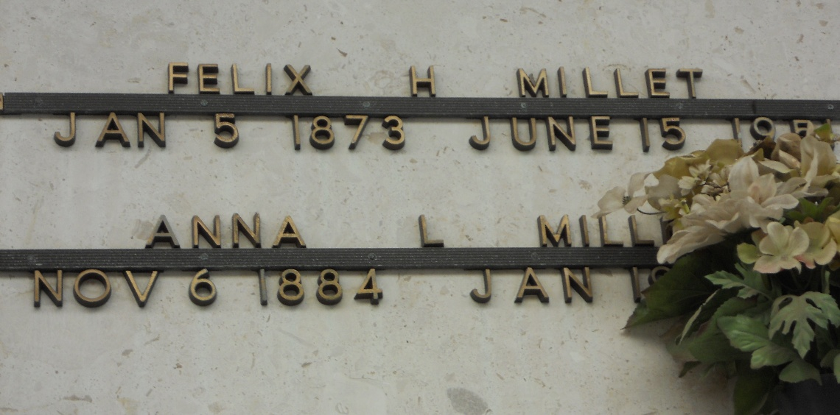
Photo by Team T-Lo

Age 78 years, husband of Anna Laiche. Father of Mrs. J. B. C. Paytavin, Mrs. Louis C. Rouillier, Mrs. C. H. Petyavin and Harold and May Millet of New Orleans, Mrs. M. H. Van Manen of League City, Texas and Felix A. Millet of Laplace, Louisiana.

Services were Sunday 17 Jun 1951 at St Hubert Church, Garyville, Louisiana, with interment in St Peter Cemetery, Reserve, Louisiana.
The Times-Picayune, New Orleans, Louisiana
17 Jun 1951

