John Sidney Millet
August 27, 1962 – November 26, 2005

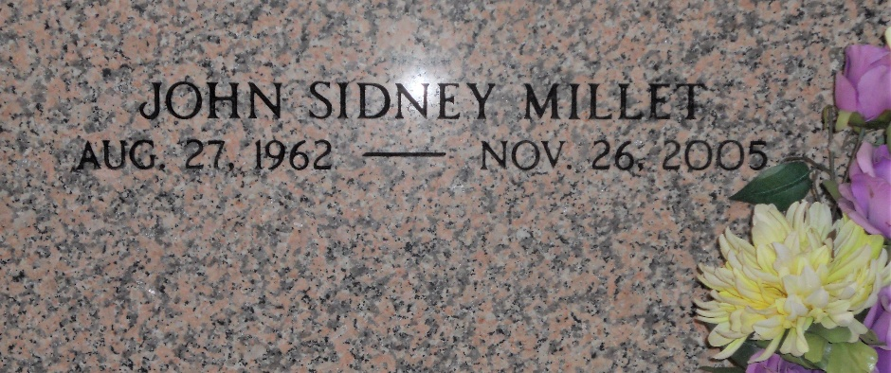
Photo by Team T-Lo

John Sidney Millet died on Saturday, Nov. 26, 2005, at 4:50 a.m. He was the beloved son of Betty Ward Millet and the late Sidney Maurice Millet Jr., brother and brother-in-law of Susan and Bruce Badeaux and Carolyn and Joseph Maples. He is also survived by a host of nieces, nephews, other relatives and friends. He was 43 years old, a native of Montz and a resident of Baton Rouge for the past 25 years.

Relatives and friends of the family, also employees of LSU, are invited to attend the service. Visiting at Millet-Guidry Funeral Home, 2806 W. Airline Highway, LaPlace, from 5 p.m. to 9 p.m. on Sunday, Nov. 27, and on Monday, Nov. 28, from 8:30 a.m. until religious service in the chapel at 10:30 a.m. Interment in St. Peter Church Cemetery, Reserve.

The Advocate, Baton Rouge, Louisiana
Nov. 27, 2005

