Joseph Ernest Millet
March 4, 1898 – February 19, 1990

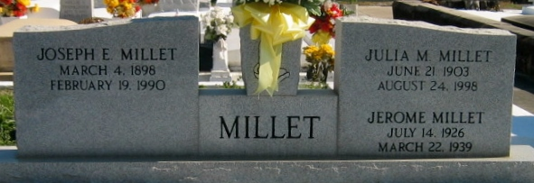
Photo by Bobby

Joseph Ernest Millet, a native and resident of Laplace, Louisiana, died Monday 19 Feb 1990 at 7:42 p.m. at age 91 years.

He was the husband of Julia Pastureau Millet and the father of Ray Millet, Mrs. Bertram (Ann) Madere and the late Jerome Millet. He was the brother of Mrs. Josepha Boudreaux and the late Marcelle Clement and Estelle Faucheaux. Also survived by 6 grandchildren and 3 great-grandchildren.

Services were Thursday 22 Feb 1990 at St Joan of Arc Catholic Church, Laplace, with interment in St Peter Cemetery, Reserve, Louisiana.
The Times-Picayune, New Orleans, Louisiana
21 Feb 1990

