Jules Peter Millet, Jr.
November 30, 1928 – June 27, 1996

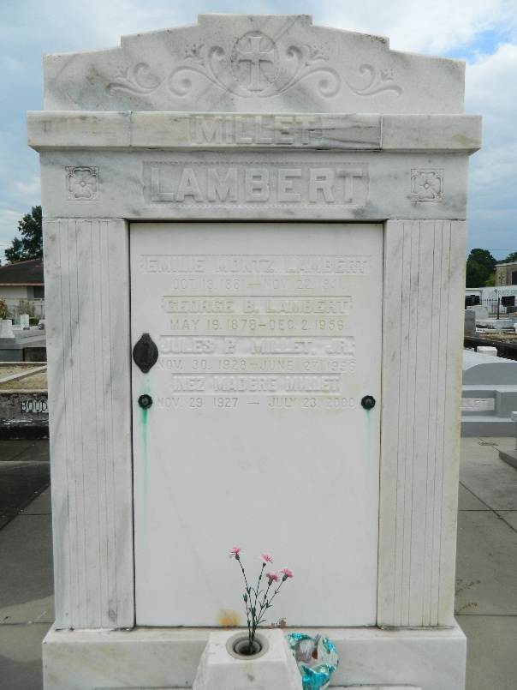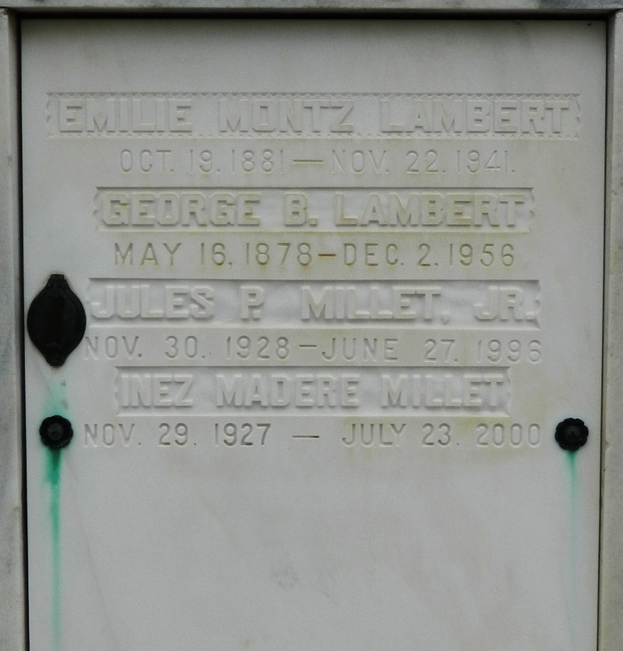

Jules P "Sonny" Millet died Thursday 27 Jun 1996 at River Parishes Hospital in Laplace, Louisiana, at age 67 years. He was a native of Garyville, Louisiana, and a resident of Reserve, Louisiana for the past 64 years. He was a Vice President for the Reserve Telephone Company. He was a graduate of St Paul's High School and worked for South Central Bell for 30 years before retiring and joining the Reserve Telephone Co Board of Directors. He was a member of The Reserve Lions Club and The Louisiana State Board of Embalmers and Funeral Directors. He also was a past Vice President of the United Appeal and an adviser for the U.S. Congressional Advisory Board.
Survivors include his wife, Inez M Millet; four daughters, Catherine I Millet, Suzanne M Kilbert, Rachel M Lehmann and Marcelle M Bailey; a son, Daniel J Millet; two sisters, Betty Lou Millet Guidry and Carolyn Millet Ourso; a brother, H David Millet; 12 grandchildren and a great-grandchild.
Services were Monday 1 Jul 1996 with interment in St Peter Cemetery, Reserve, Louisiana.
The Times-Picayune, New Orleans, Louisiana
June 30, 1996

