Julia M. (Pastureau) Millet
June 21, 1903 – August 24, 1998

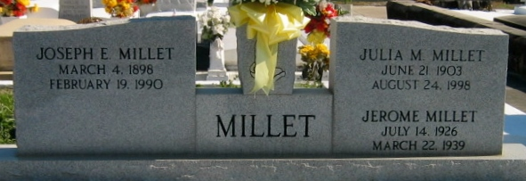
Photo by Bobby

Julia Pastureau Millet, a native and resident of Laplace, Louisiana, died Monday 24 Aug 1998 at 9:30 a.m. at age 95 years.

She was the wife of the late Joseph E Millet and the mother of Ray Millet, Mrs. Bertram (Ann) Madere and the late Jerome Millet. She was the daughter of the late Jules and Octavie Dufresne Pastureau and the sister of Adela Mauterer, Albert Pastureau and the late Ida Ryckeley. Also survived by 6 grandchildren and 11 great-grandchildren.

Services were Thursday, 27 Aug 1998 at St Joan of Arc Catholic Church, Laplace, with interment in St Peter Cemetery, Reserve, Louisiana.
The Times-Picayune, New Orleans, Louisiana
August 25, 1998

