Laure Millet
September 14, 1864 – May 24, 1948

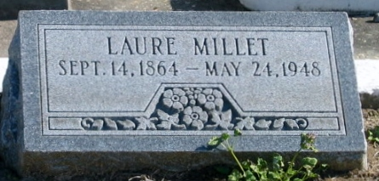
Photo by Bobby

MILLET

At Laplace, La, on Monday, May 24, 1948, at 7 o'clock a.m., LAURE MILLET, sister of Noe Millet of Laplace, La., Ellis Millet of Baton Rouge, La., and Mrs. Charles Tassin of Edgard, La., aged 83 years.

Relatives and friends of the family are invited to attend the funeral, which will take place from the Millet Funeral Home, Reserve, La, on Tuesday morning, May 25, 1948, at 9:30 o'clock, followed by religious services at St Peter church, Reserve, La. Interment in St Peter cemetery, Reserve, La.

The Times-Picayune, New Orleans, Louisiana
25 May 1948, p. 2

