Leo Anthony Millet Jr.
December 2, 1918 – December 7, 2001

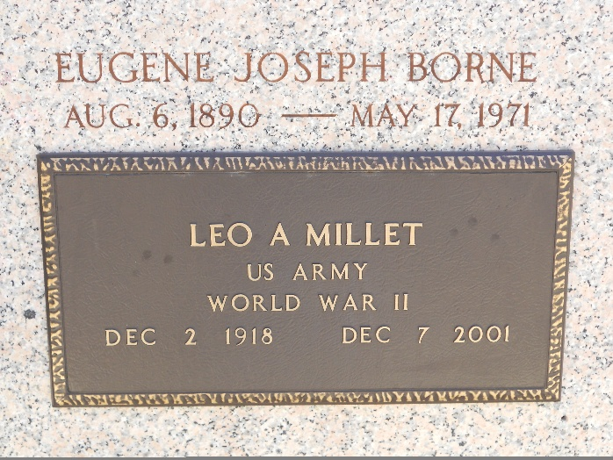
Photo by Team T-Lo

METAIRIE - Leo A. Millet, 83, a native of Garyville and resident of New Orleans, died Dec. 7.

He was the husband of the late Mildred Borne. He was the son of the late Alexander and Leo A. Millet and brother of Jacqueline Kern, Minnette Montegut, Carol Vicknair, Gwendolyn Lemonier and Dorothy, Barbara, Roland, Lyle, David and Jean Millet. He was a retired federal employee and a World War II veteran.

Services were held Dec. 8 in the chapel of Leitz-Eagan Funeral Home, Metairie, with interment at St. Peter Cemetery, Reserve.
L'Observateur, LaPlace, Louisiana
December 15, 2001

