Louise (Vicknair) Millet
June 29, 1914 – May 10, 2007

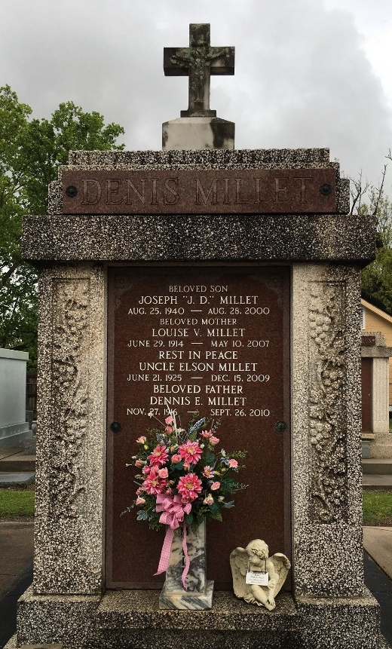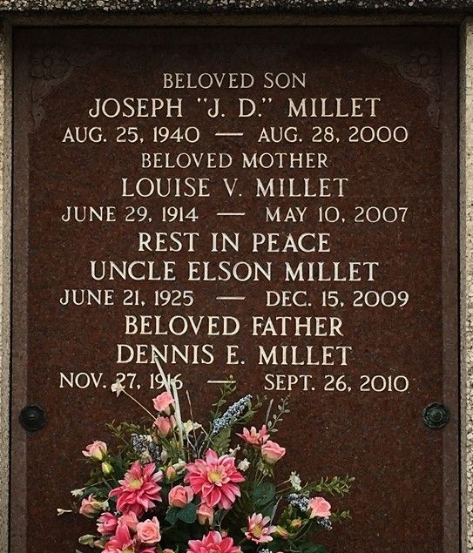
Photo by Team T-Lo

Louise Vicknair Millet died on Thursday 10 May 2007 at 12:47 pm at age 92 years.
She was a native and resident of Reserve, Louisiana, and the wife of Dennis Millet. She was the mother of Clarence Millet and the late Joseph (JD) Millet. She was the daughter of the late Frank and Mollie Bossier Vicknair, and sister of the late Caffrey, Michel, Fortune and Trezema Vicknair, Leontine Luminais, Juliet Lacour, Adele Cambre and Viola St Martin.
Services were Saturday, 12 May 2007 at St Peter Catholic Church, Reserve, with interment in St Peter Cemetery.
The Times-Picayune, New Orleans, Louisiana
11 May 2007

